Garage System Questions.👇👇👇



**Q.1 List all the customers serviced.**

Query :

SELECT customer.CNAME, SER_DET.CID

from customer inner join SER_DET



on customer.CID=SER_DET.CID;



**Q.2 Customers who are not serviced.**

Query: select customer.CNAME,SER_DET.CID

from customer LEFT JOIN on SER_DET

on customer.CID=SER_DET.CID;

where SER_DET.CID is null;

OR

Create view notserviced as

select customer.CNAME,SER_DET.CID

from customer LEFT JOIN on SER_DET

on customer.CID=SER_DET.CID

select CNAME from notserviced

where notserviced.CID is null

**Q.3 Employees who have not received the commission.**

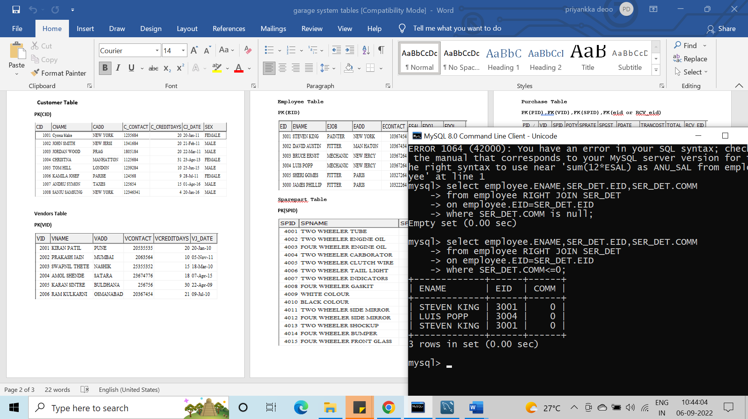

**Q.4 Name the employee who have maximum Commission.**

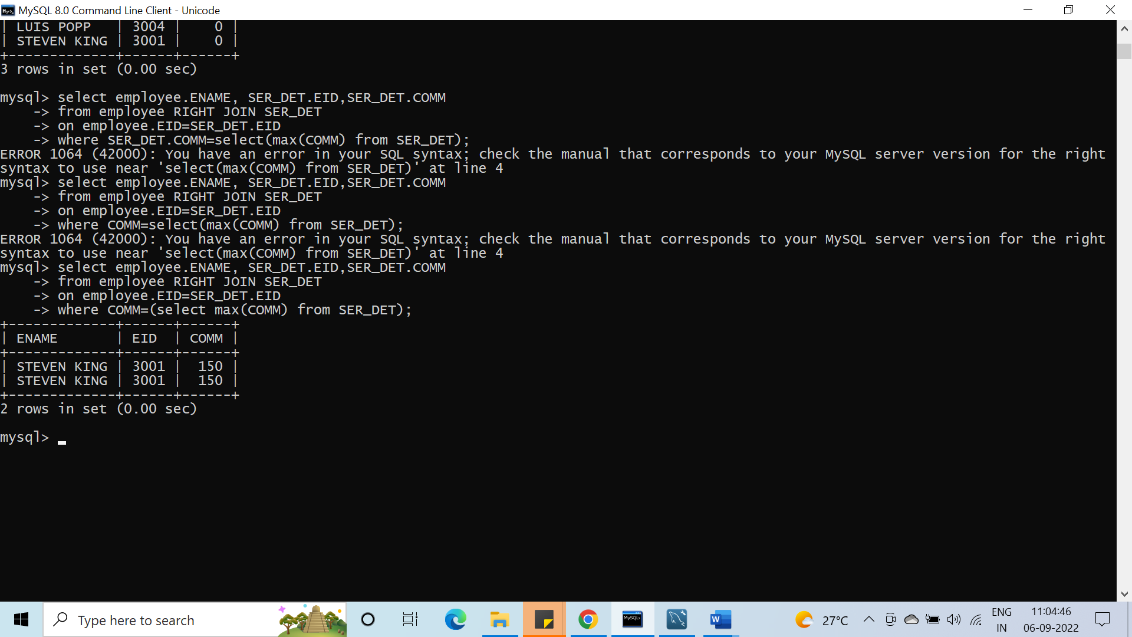

**Q.5 Show employee name and minimum commission amount received by an employee.**

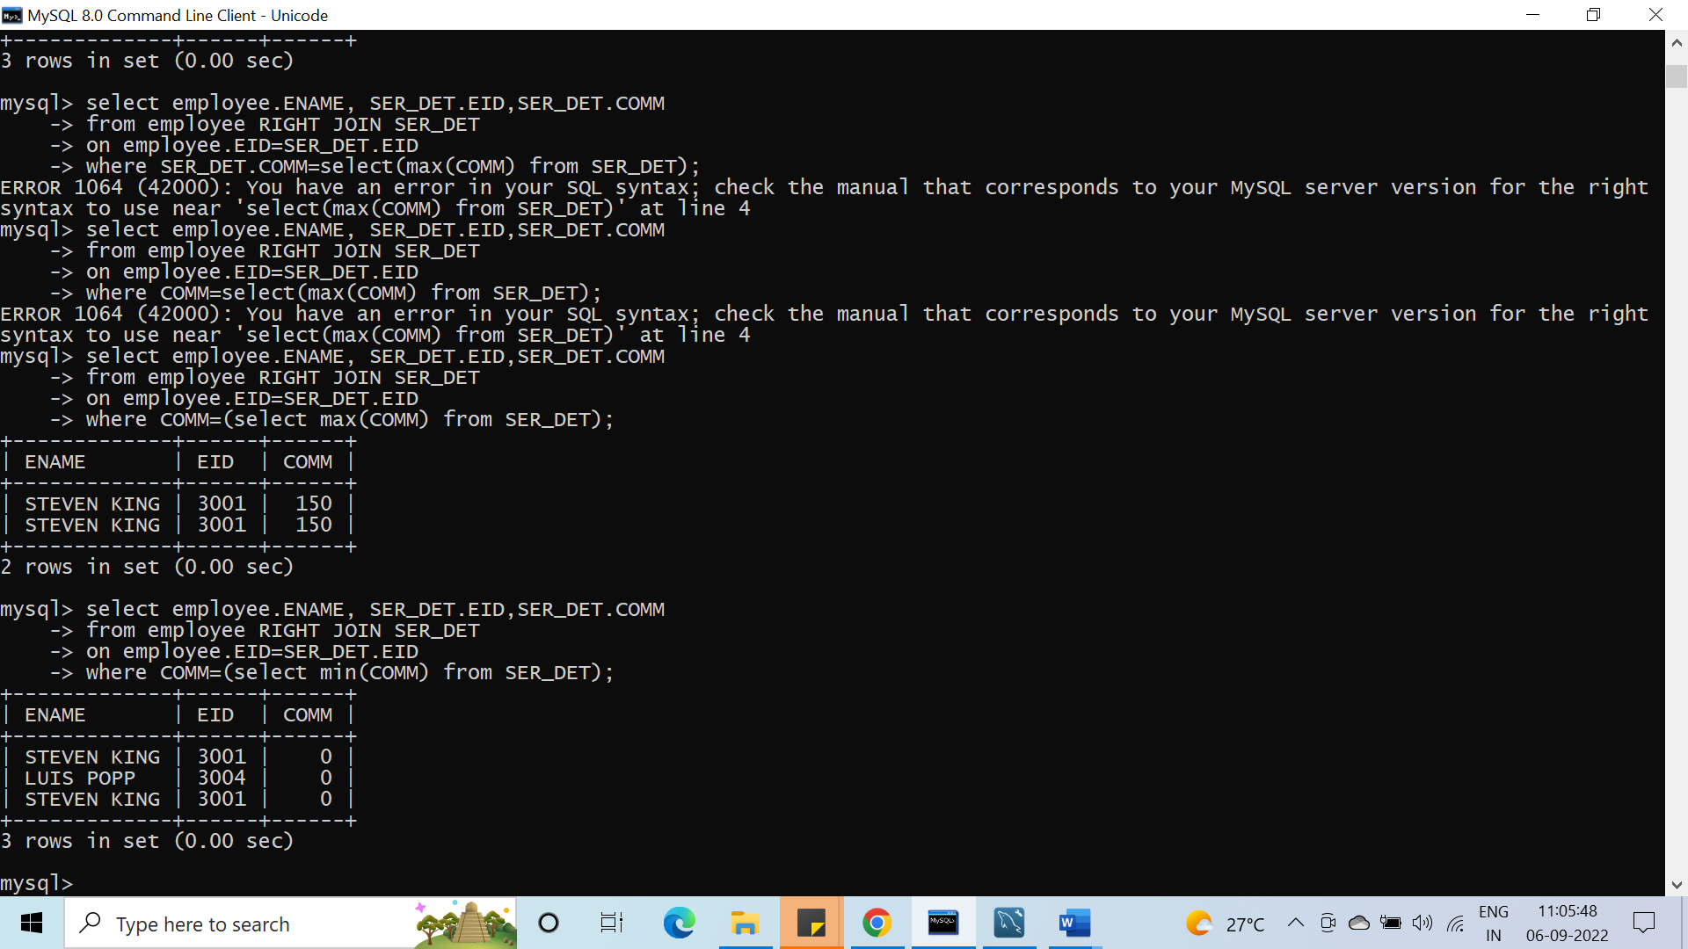

**Q.6 Display the Middle record from any table.**

**Limit count(EID)/2 ,-1**

**Q.7 Display last 4 records of any table.**

Select * from employee

Order by EID DESC LIMIT 4 ;

**Q.8 Count the number of records without count function from any table.**

With COUNT

Select count (*) from employee;

WITHOUT COUNT

**Q.9 Delete duplicate records from "Ser_det" table on cid.(note Please rollback after execution).**

**Q.10 Show the name of Customer who have paid maximum amount**

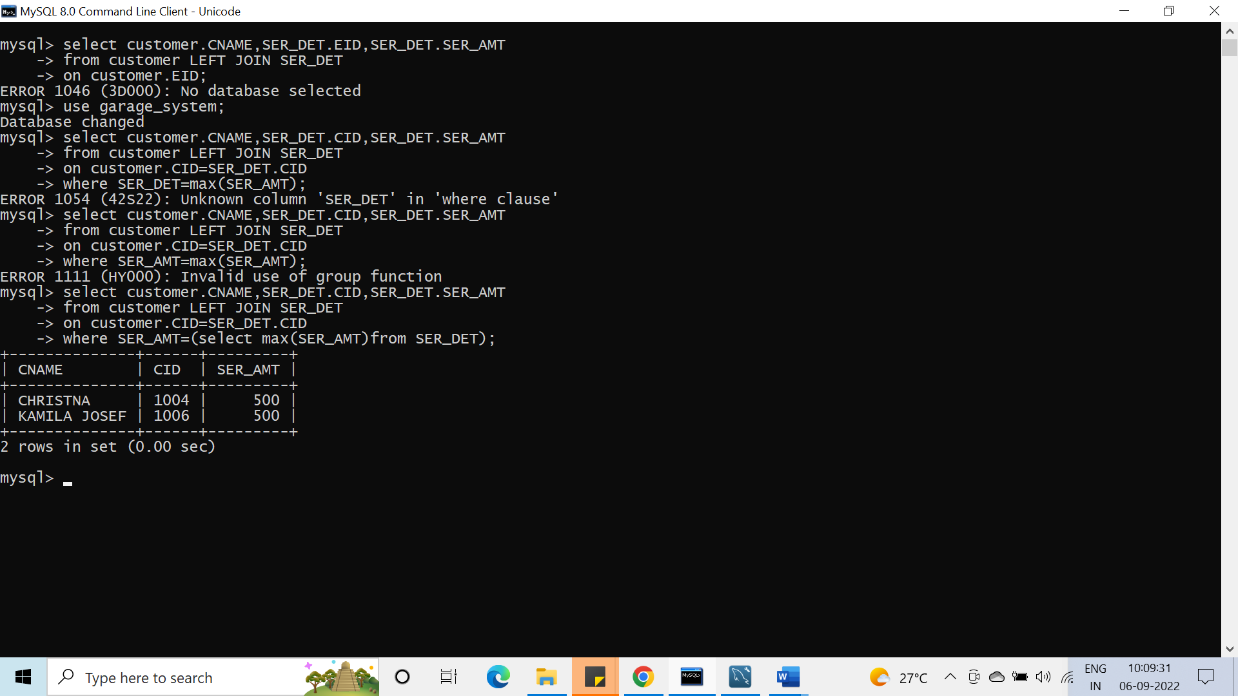

**Q.11 Display Employees who are not currently working.**

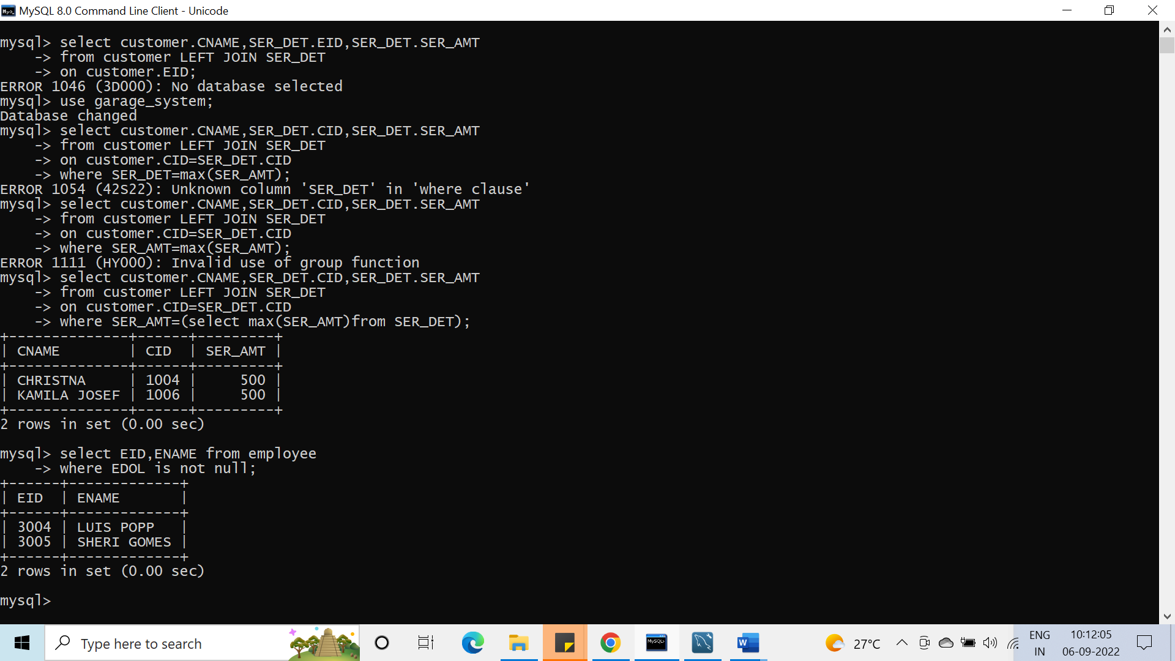

**Q.12 How many customers serviced their two wheelers.**

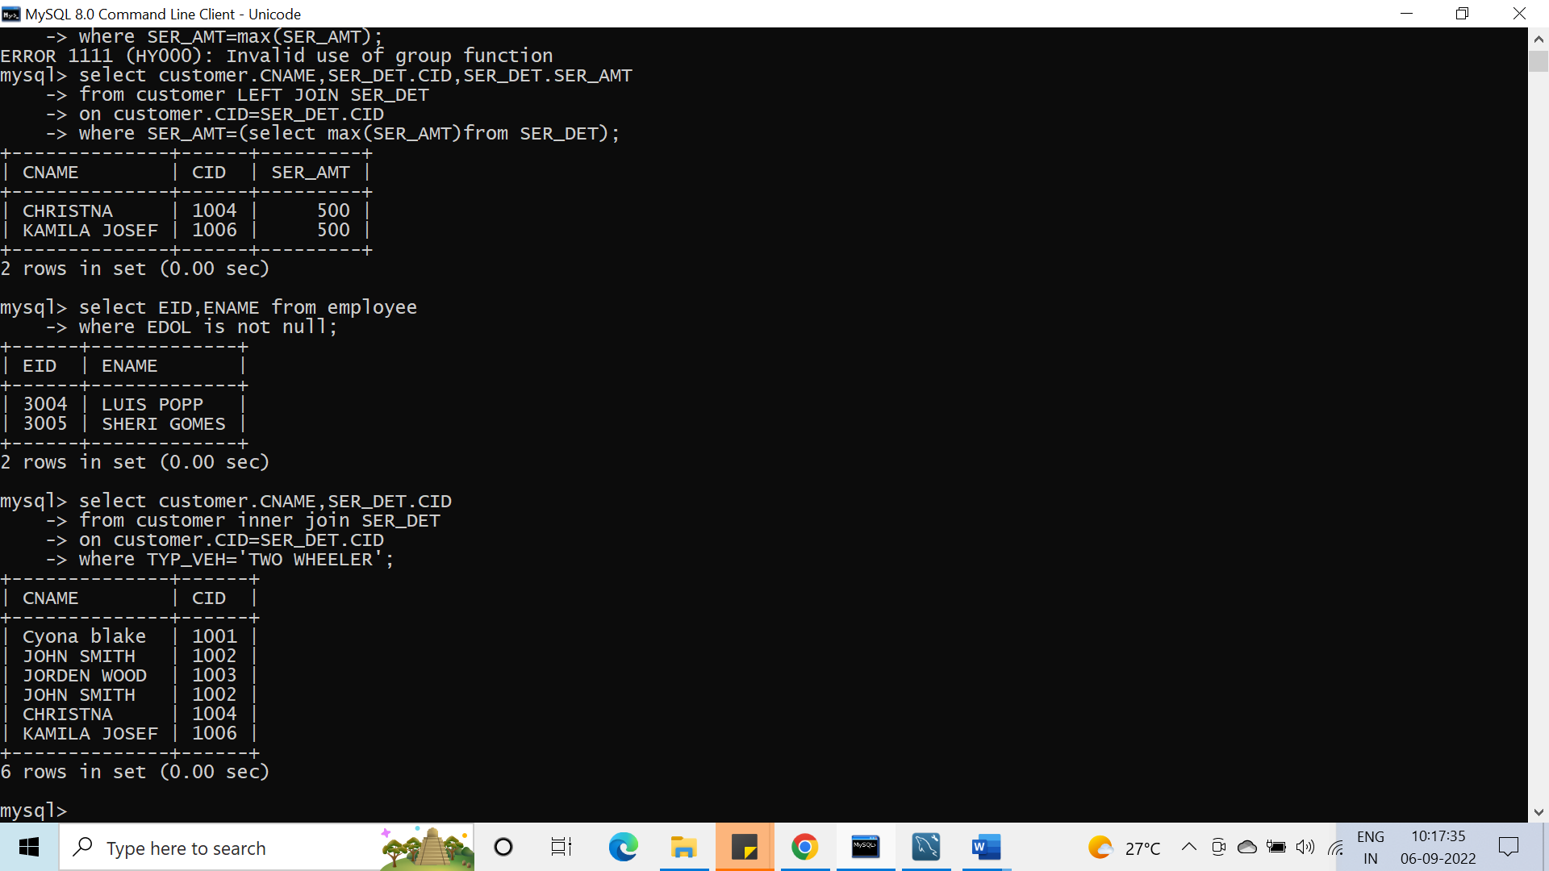

**Q.13 List the Purchased Items which are used for Customer Service with Unit of that Item.**

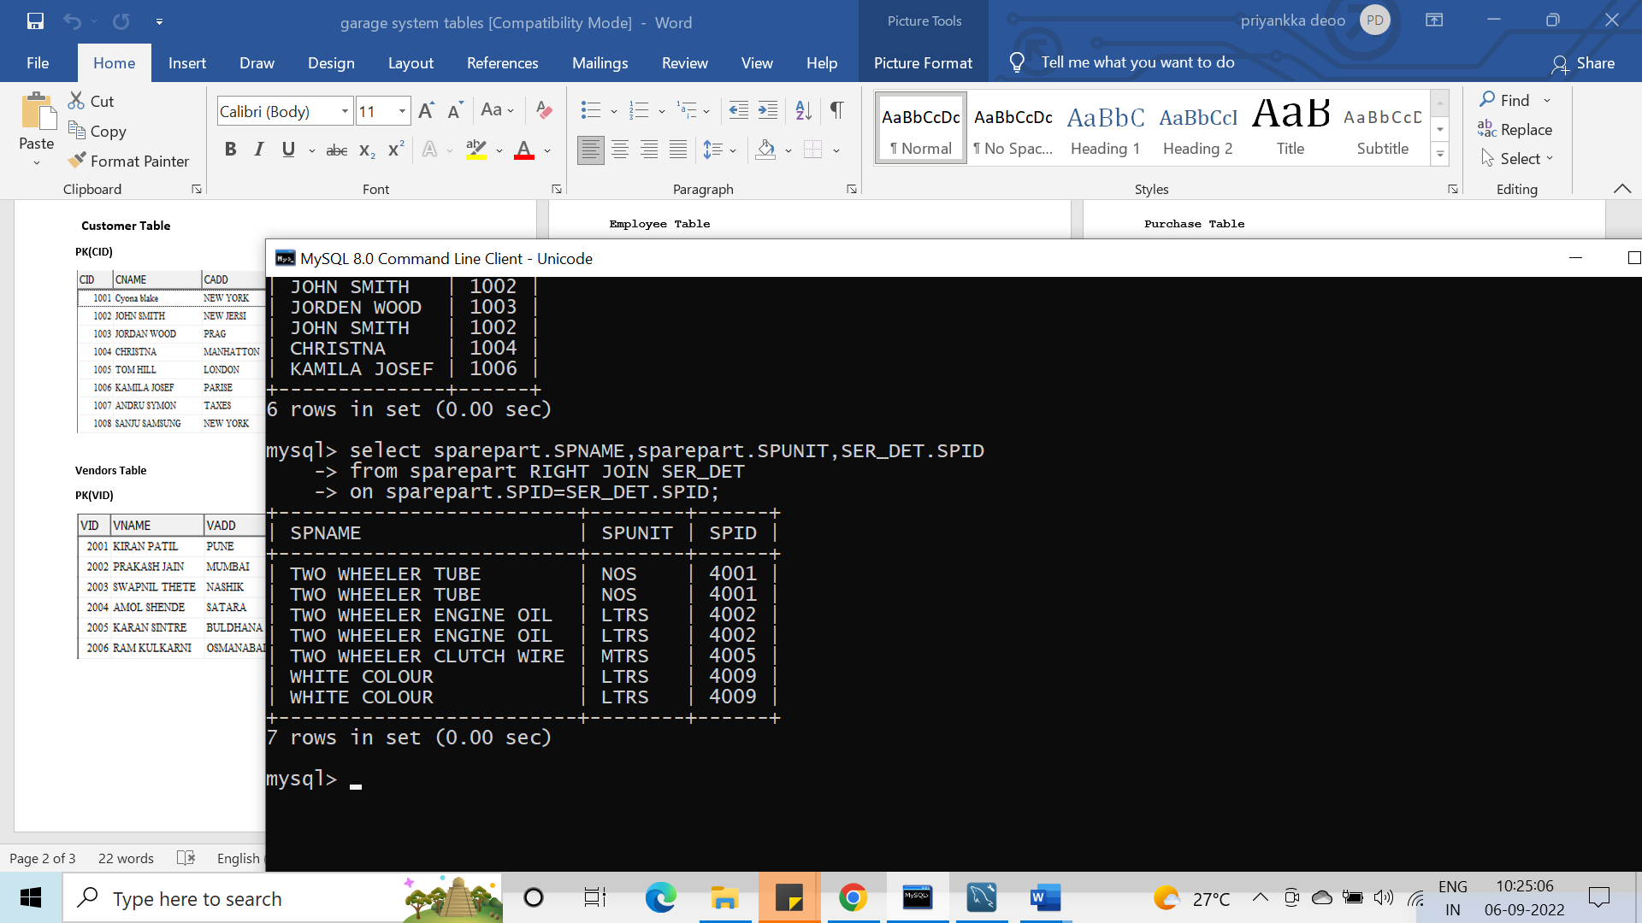

**Q.14 Customers who have Coloured their vehicles.**

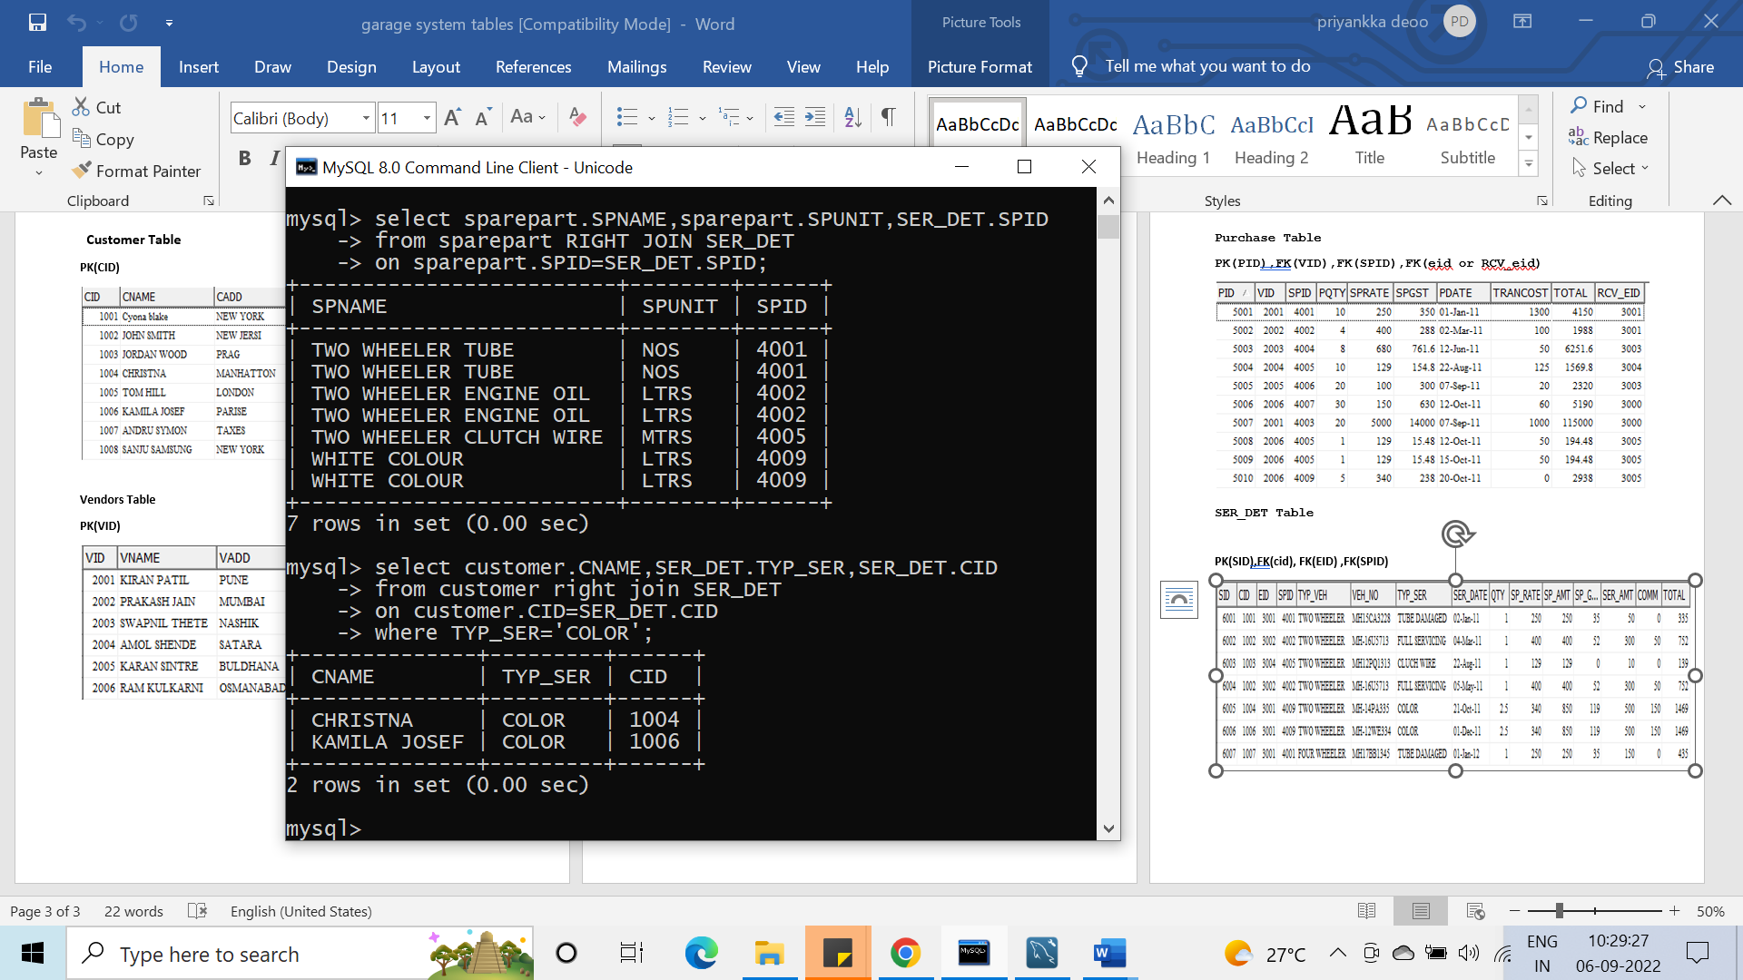

**Q.15 Find the annual income of each employee inclusive of Commission**

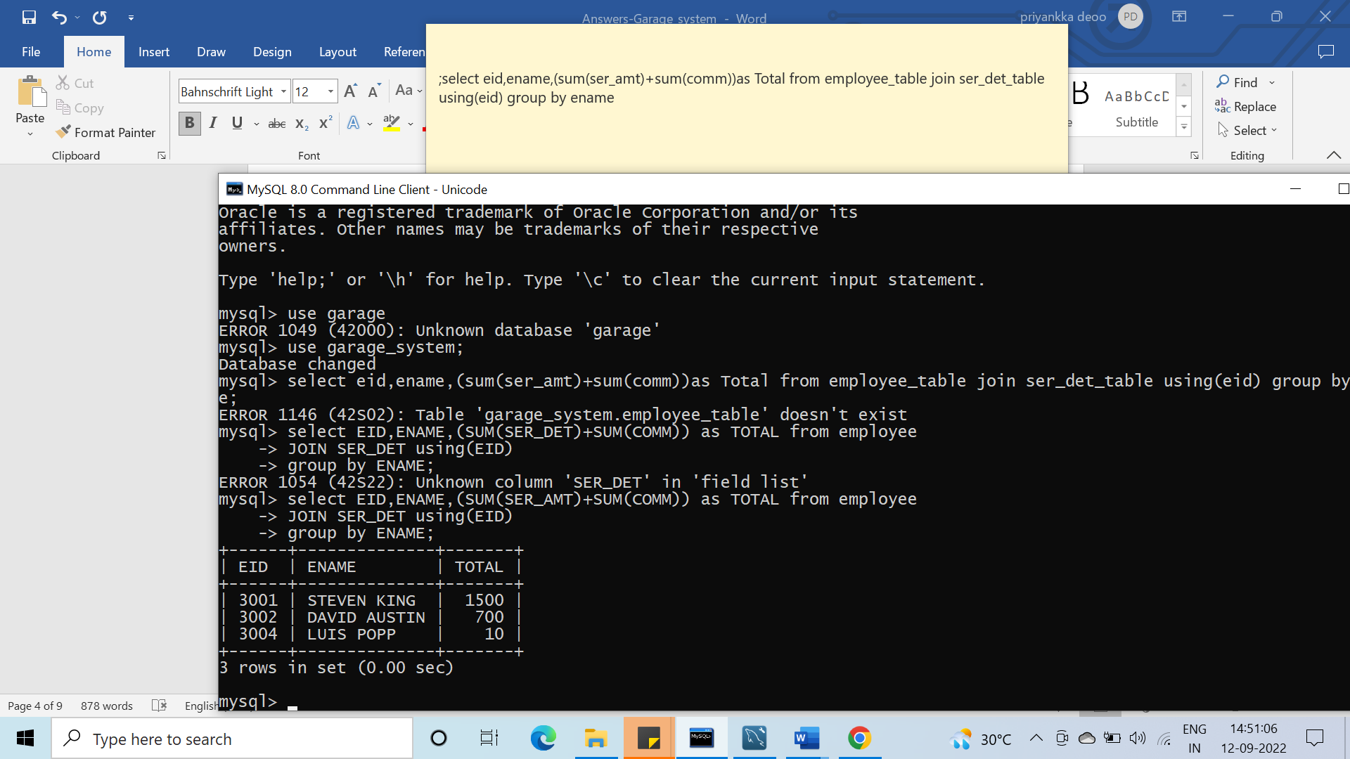

**Q.16 Vendor Names who provide the engine oil.**

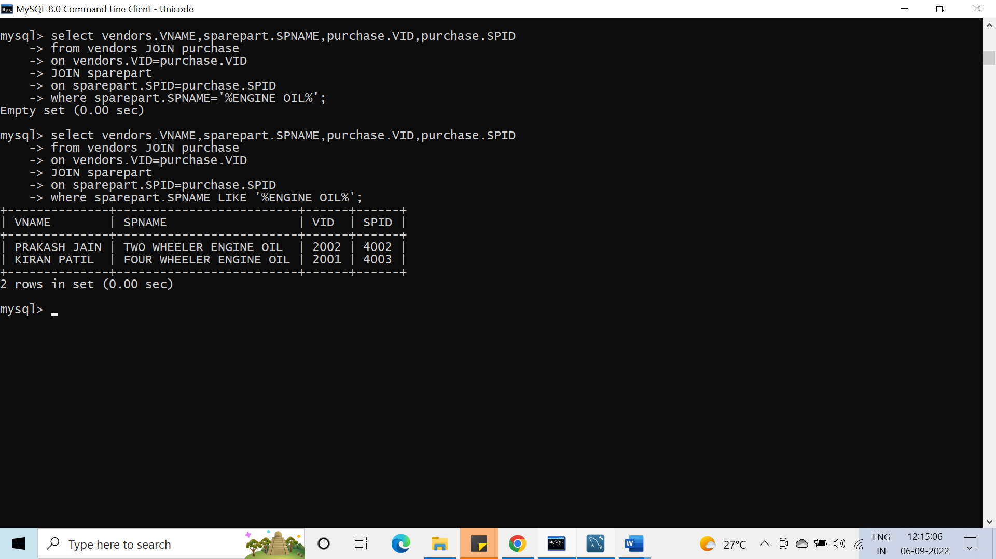

**Q.17 Total Cost to purchase the Color and name the color purchased.**

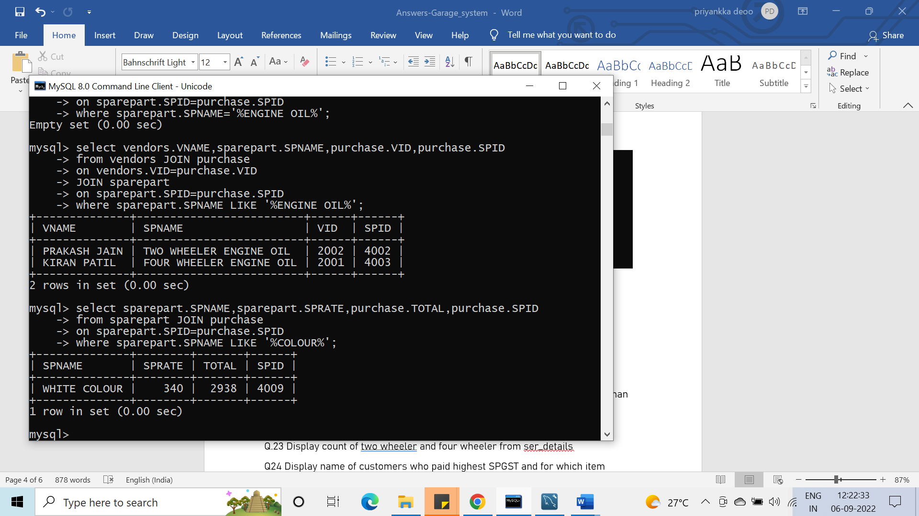

**Q.18 Purchased Items which are not used in "Ser_det".**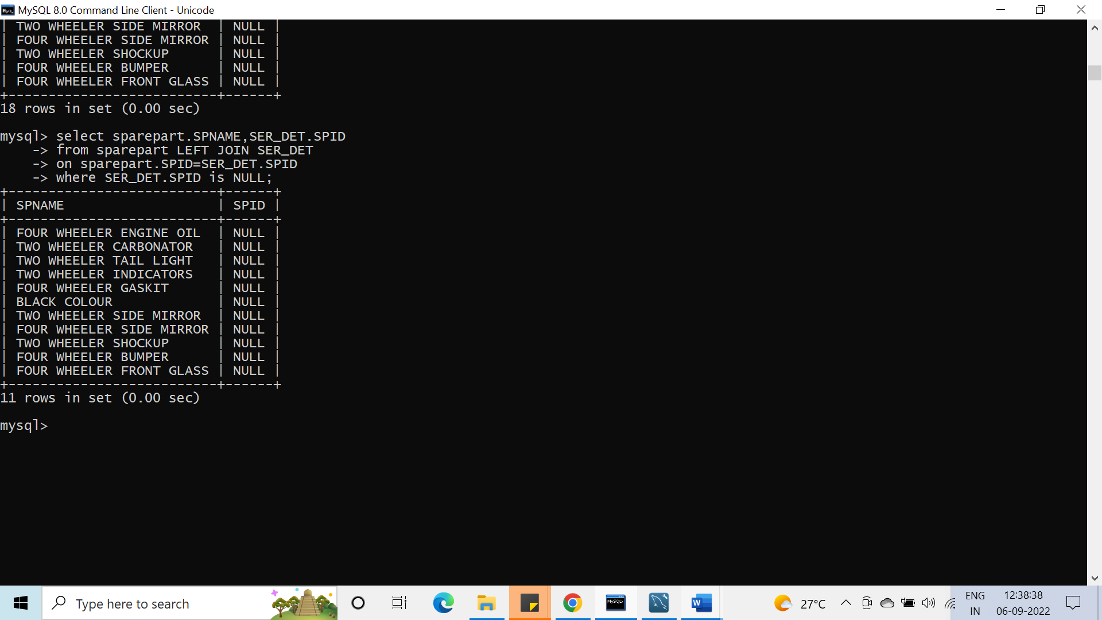

**Q.19 Spare Parts Not Purchased but existing in Sparepart**

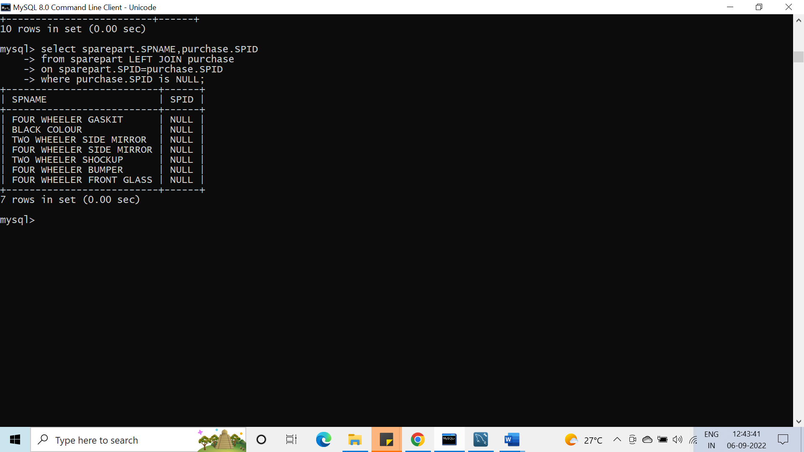

**Q.20 Calculate the Profit/Loss of the Firm. Consider one month salary of each employee for Calculation.**

**Q.21 Specify the names of customers who have serviced their vehicles more than one time.**

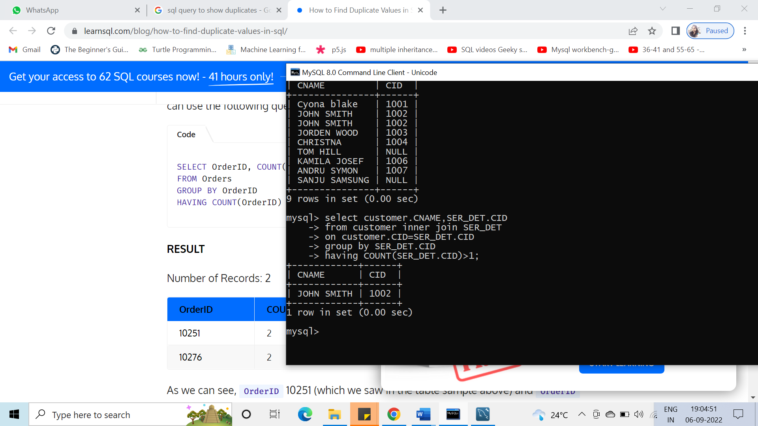

**Q.22 List the Items purchased from vendors locationwise.**

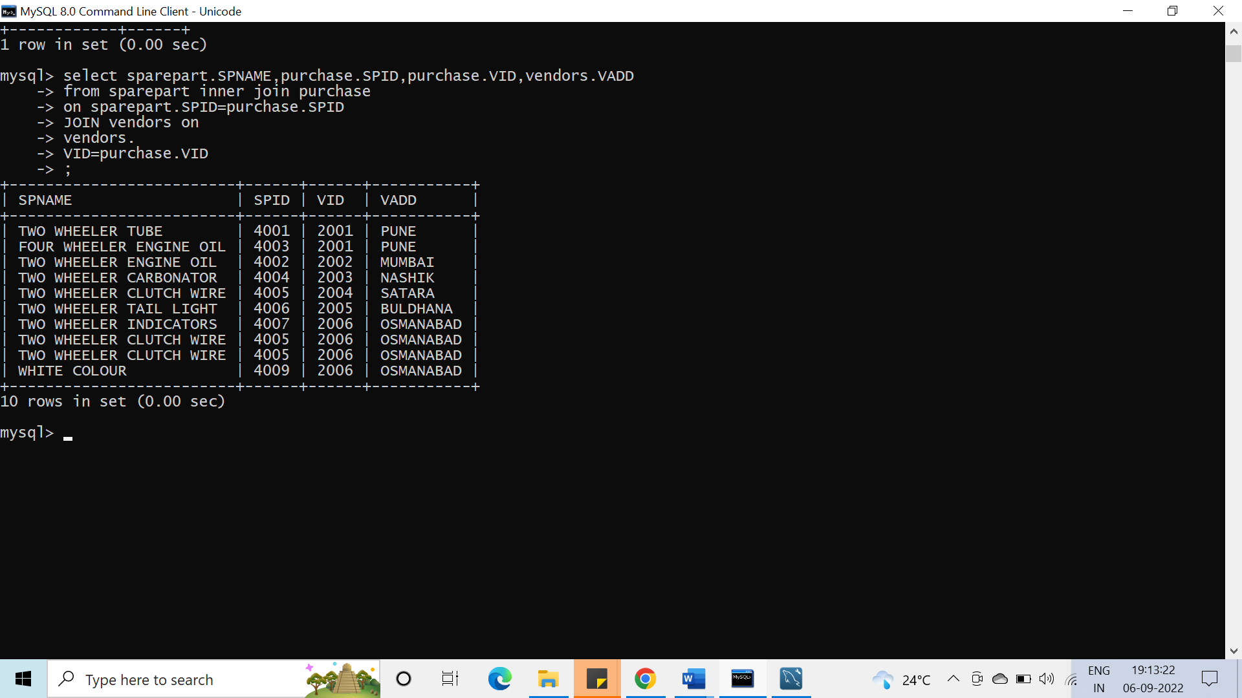

**Q.23 Display count of two wheeler and four wheeler from ser_details**

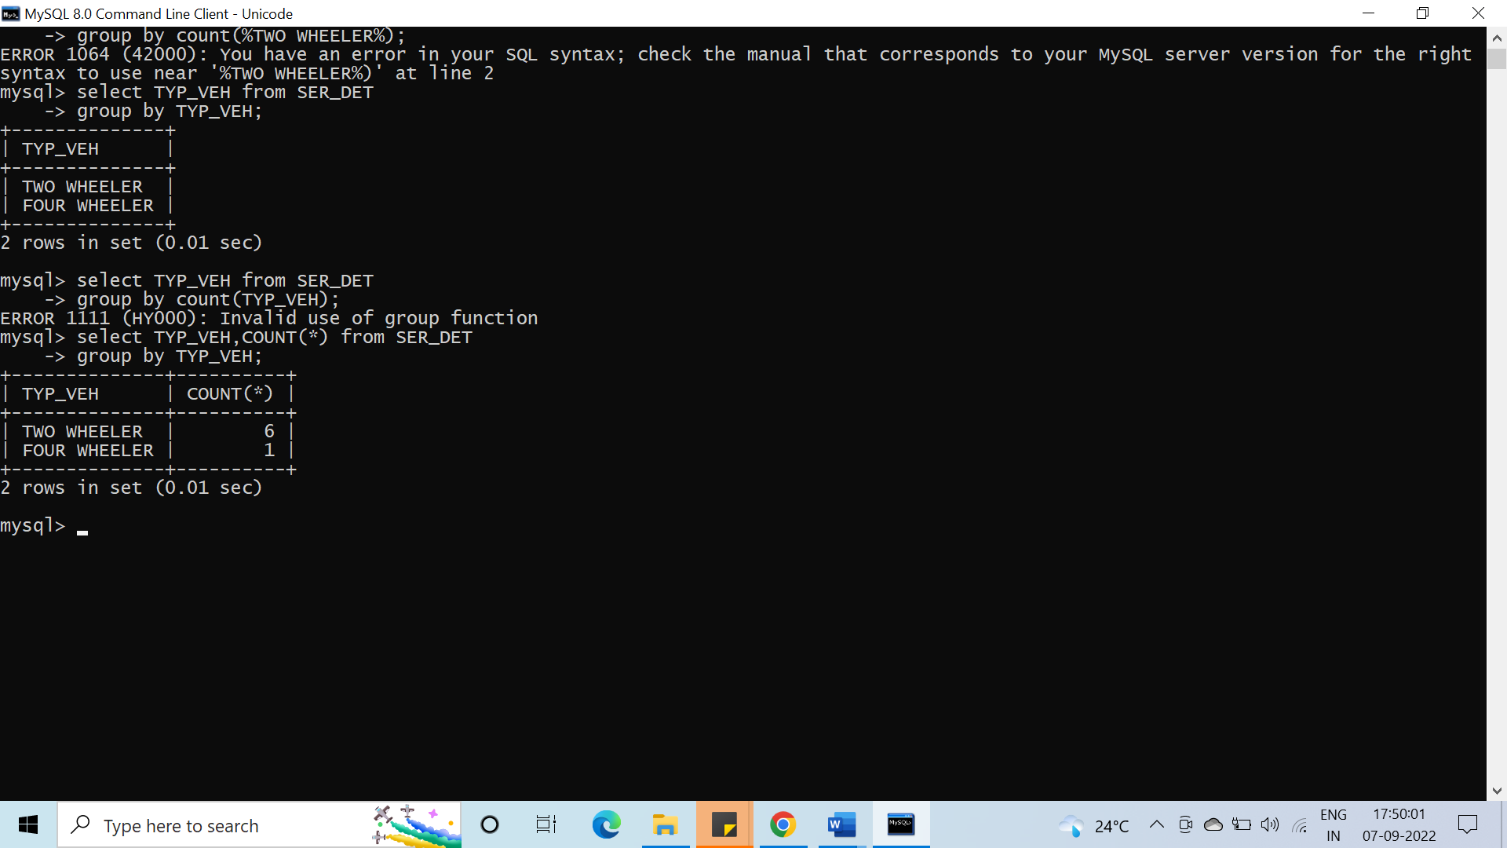

**Q24 Display name of customers who paid highest SPGST and for which item**

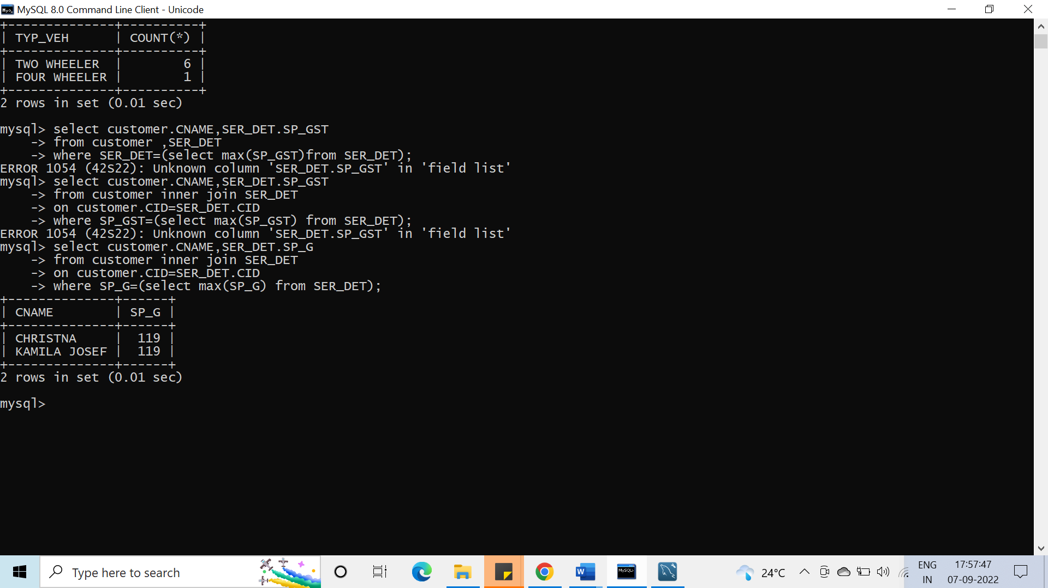

**Q25 Display vendors name who have charged highest SPGST rate for which item**

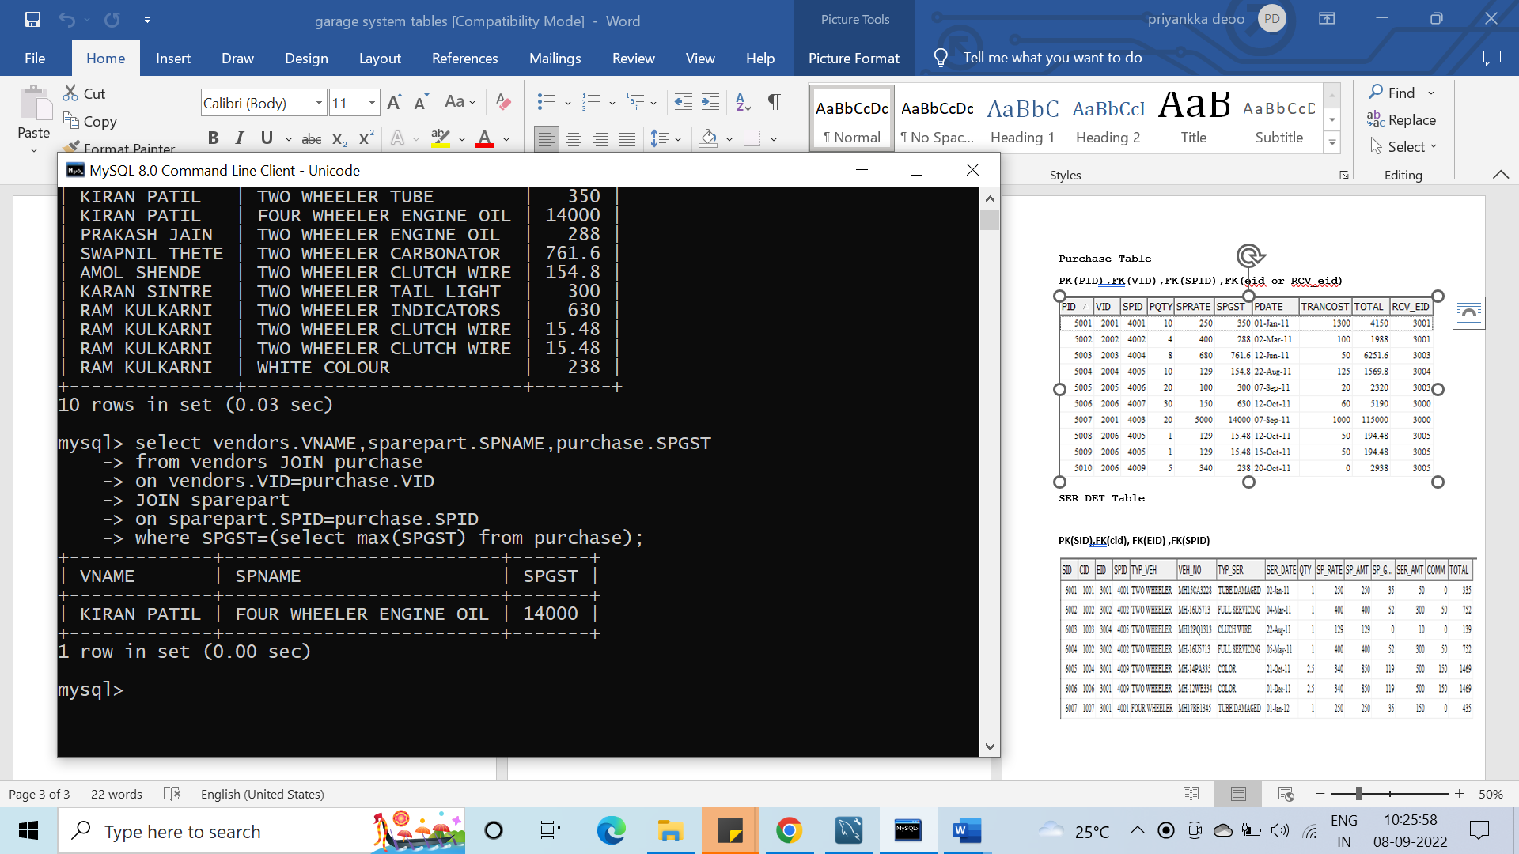

**Q26 list name of item and employee name who have received item**

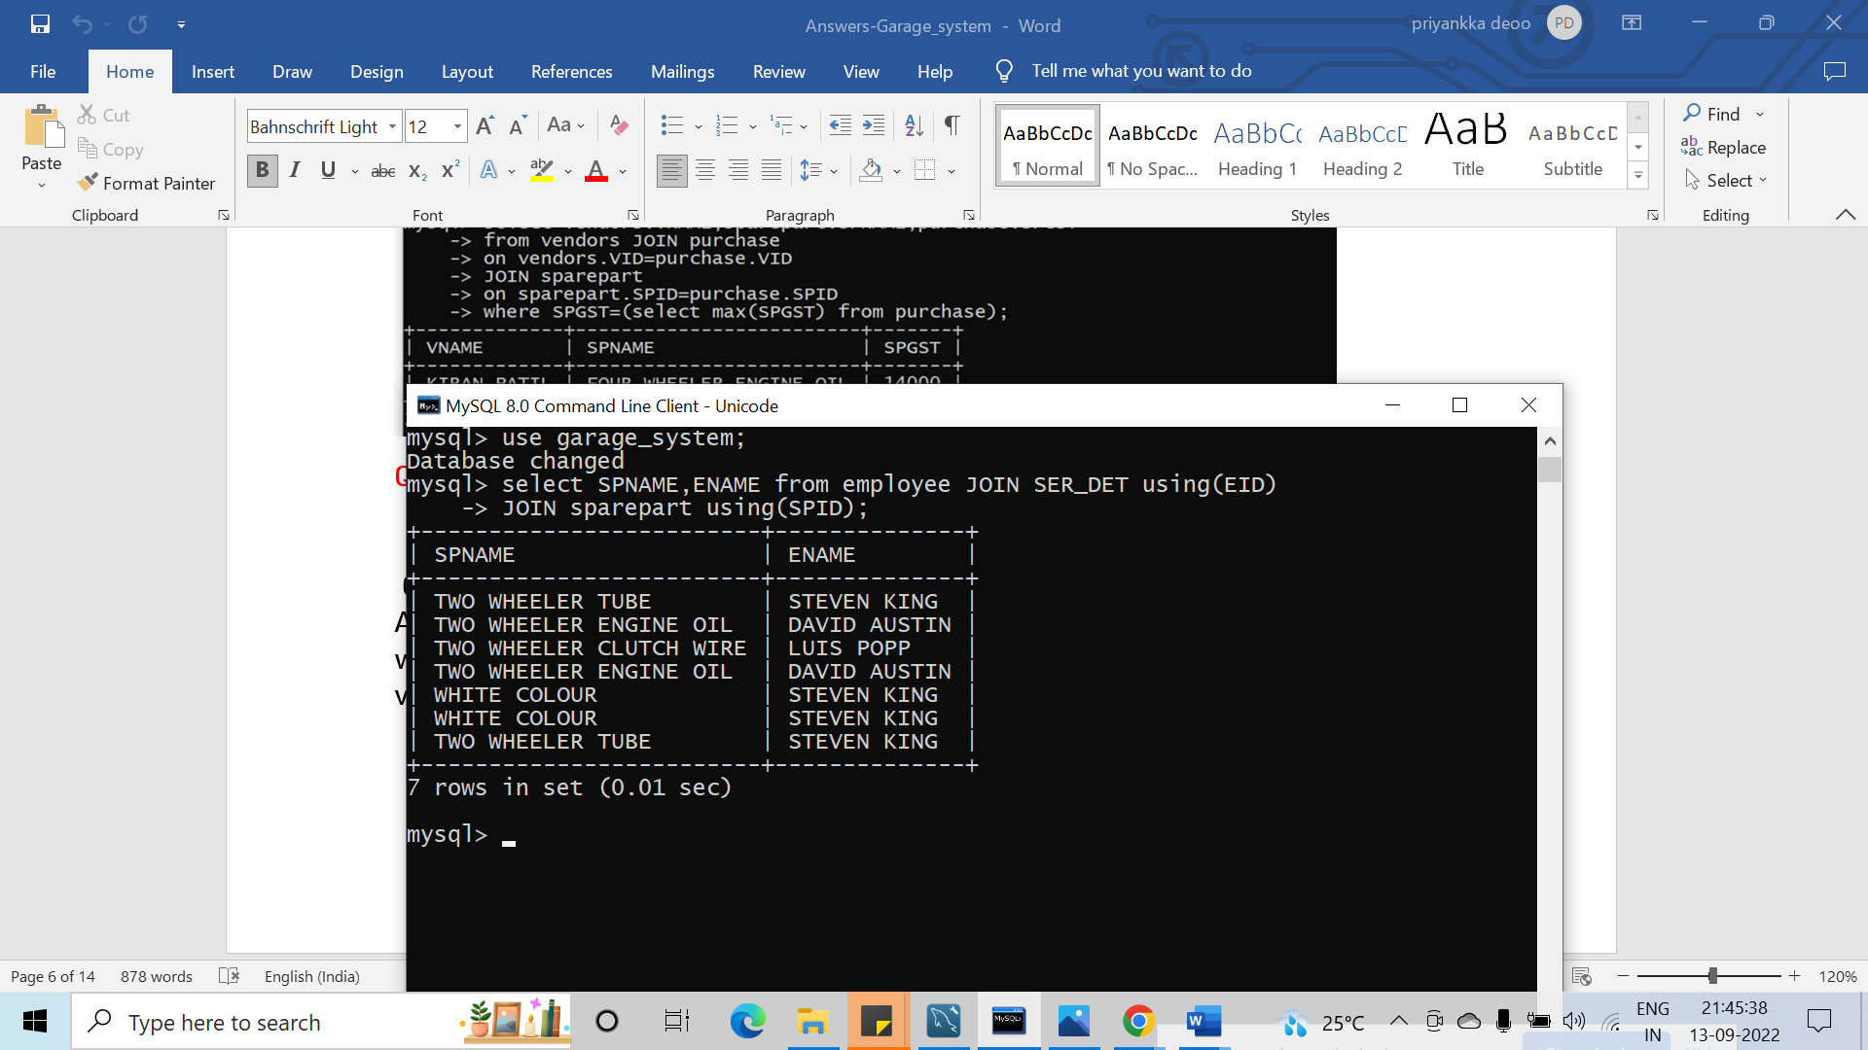

**Q27 Display the Name and Vehicle Number of Customer who serviced his vehicle, And Name the Item used for Service, And specify the purchase date of that Item with his vendor and Item Unit and Location, And employee Name who serviced the vehicle. for Vehicle NUMBER "MH-14PA335".'**

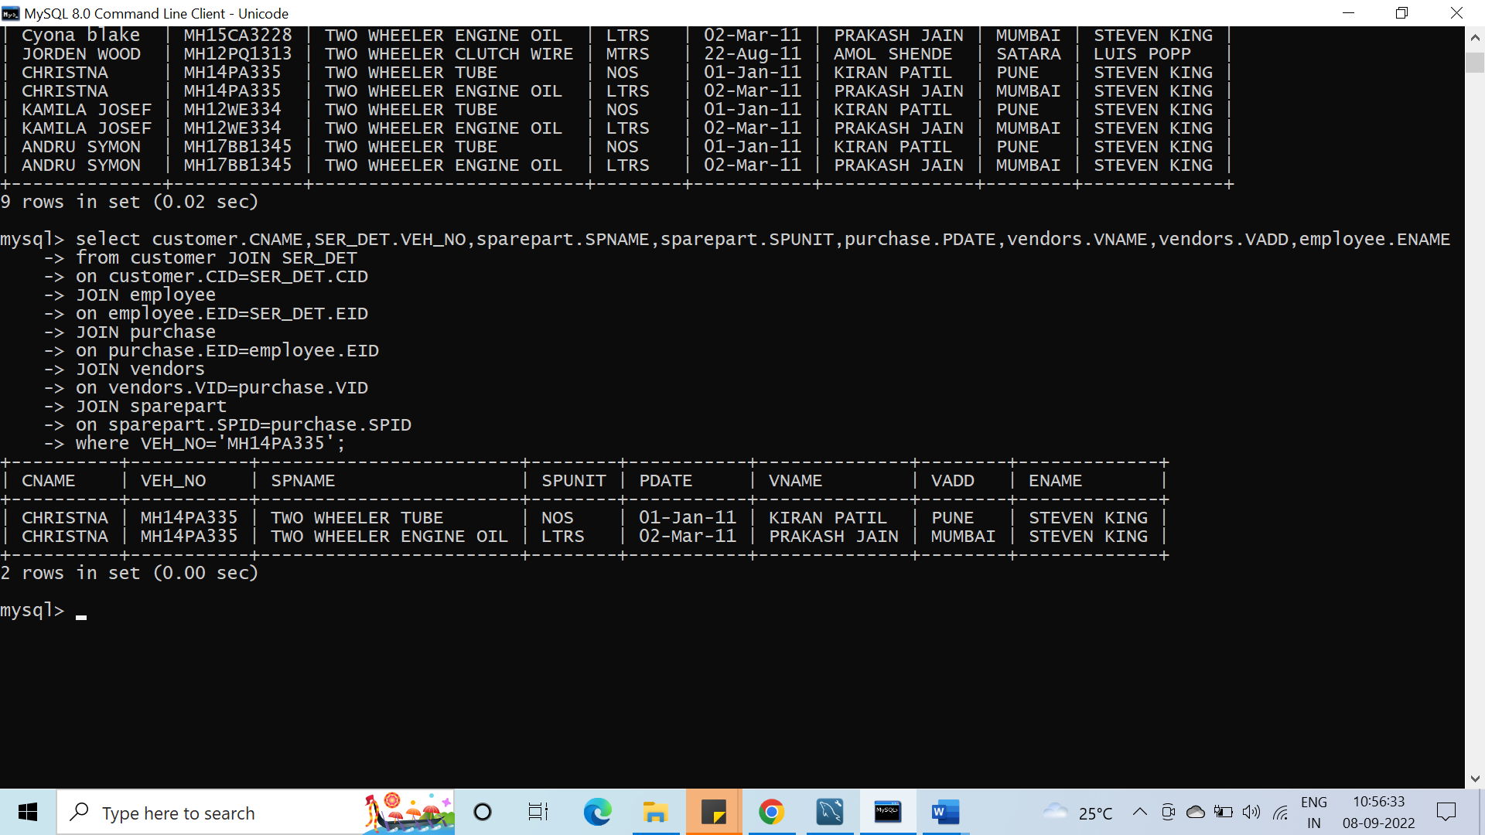

**Q28 who belong this vehicle MH-14PA335" Display the customer name**

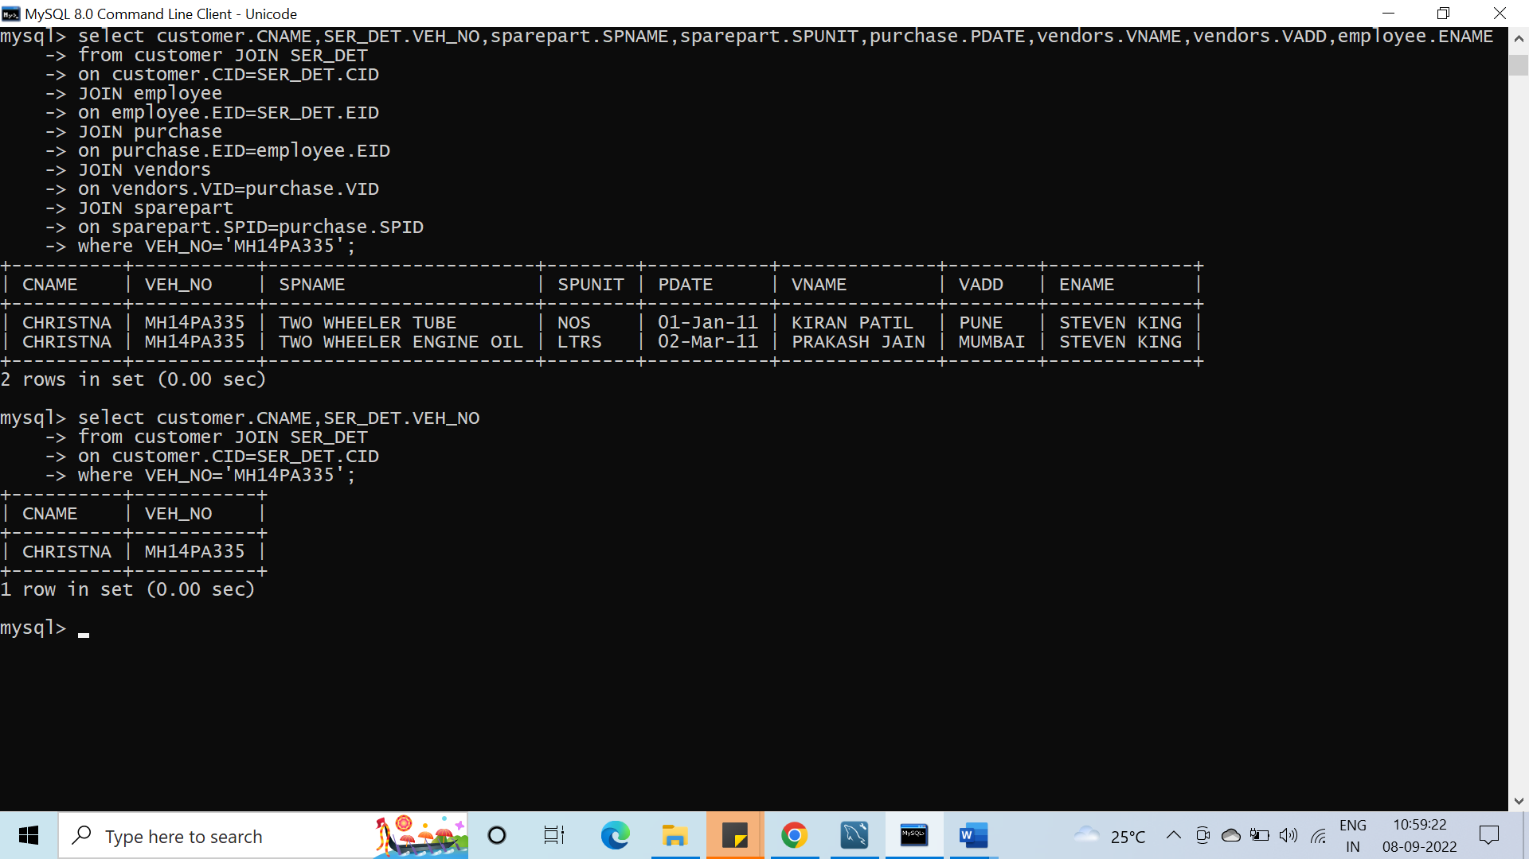

**Q29 Display the name of customer who belongs to New York and when he /she service their vehicle on which date**

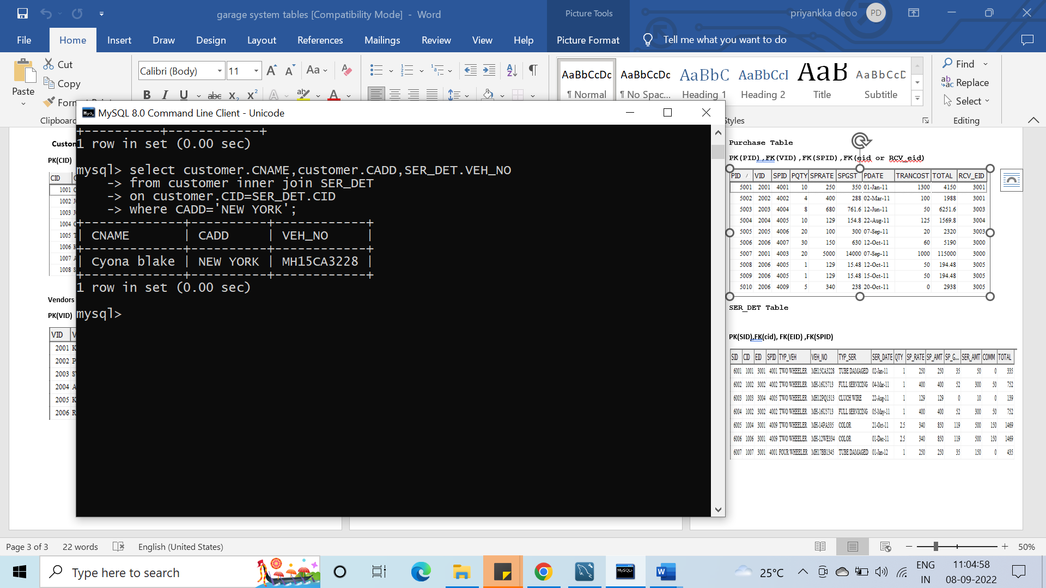

**Q 30 from whom we have purchased items having maximum cost?**

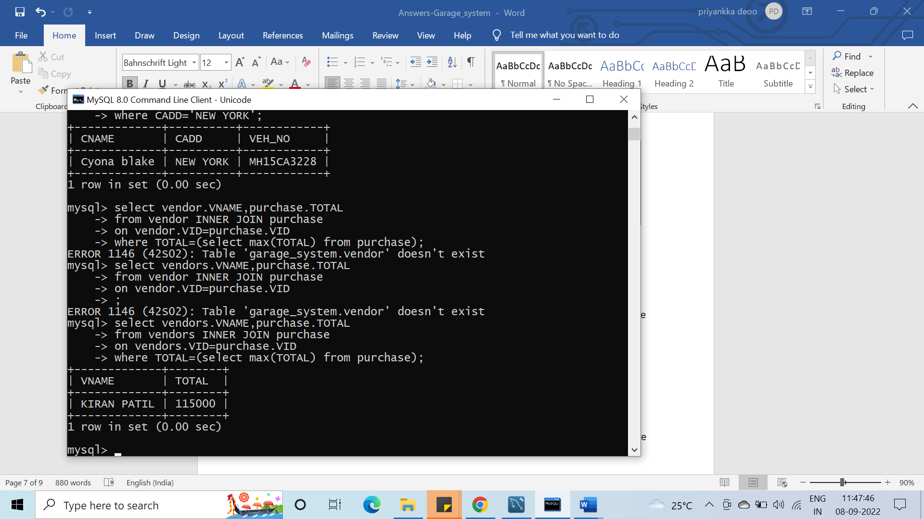

**Q31 Display the names of employees who are not working as Mechanic and that employee done services.**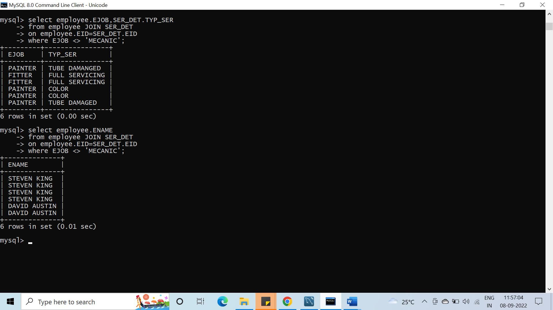

**Q32 Display the various jobs along with total number of employees in each job. The output should**

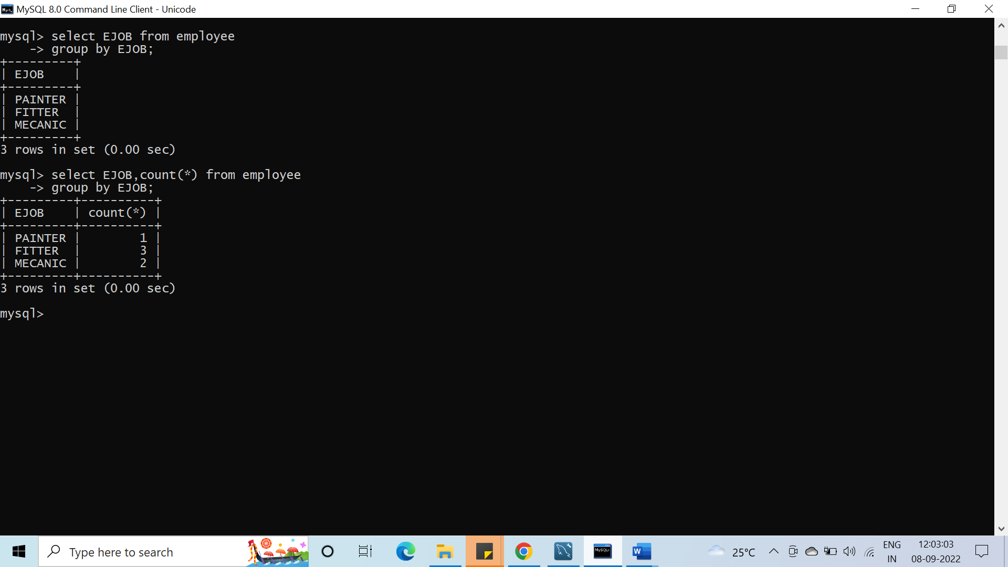

**contain only those jobs with more than two employees.**

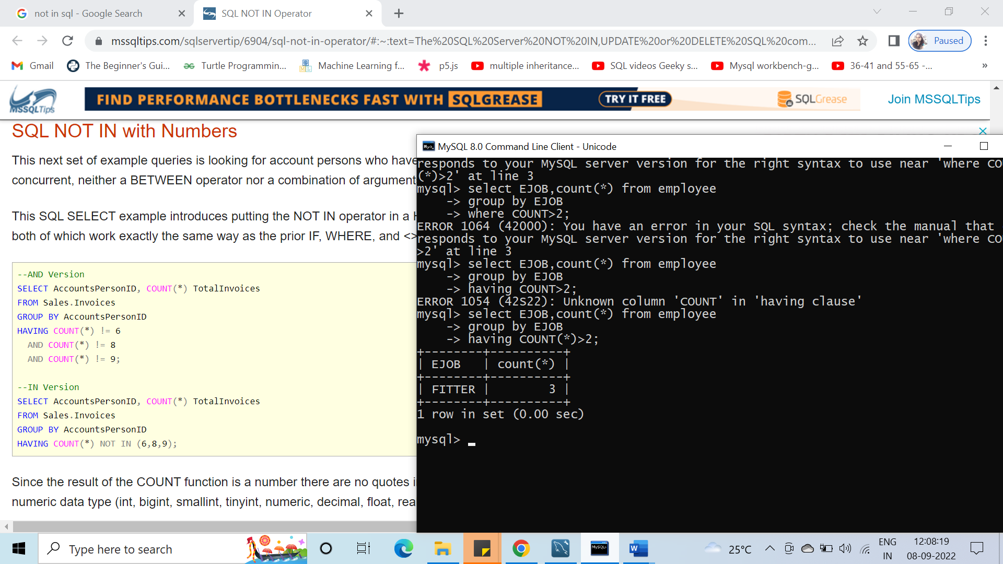

**Q33 Display the details of employees who done service and give them rank according to their no. of services**.

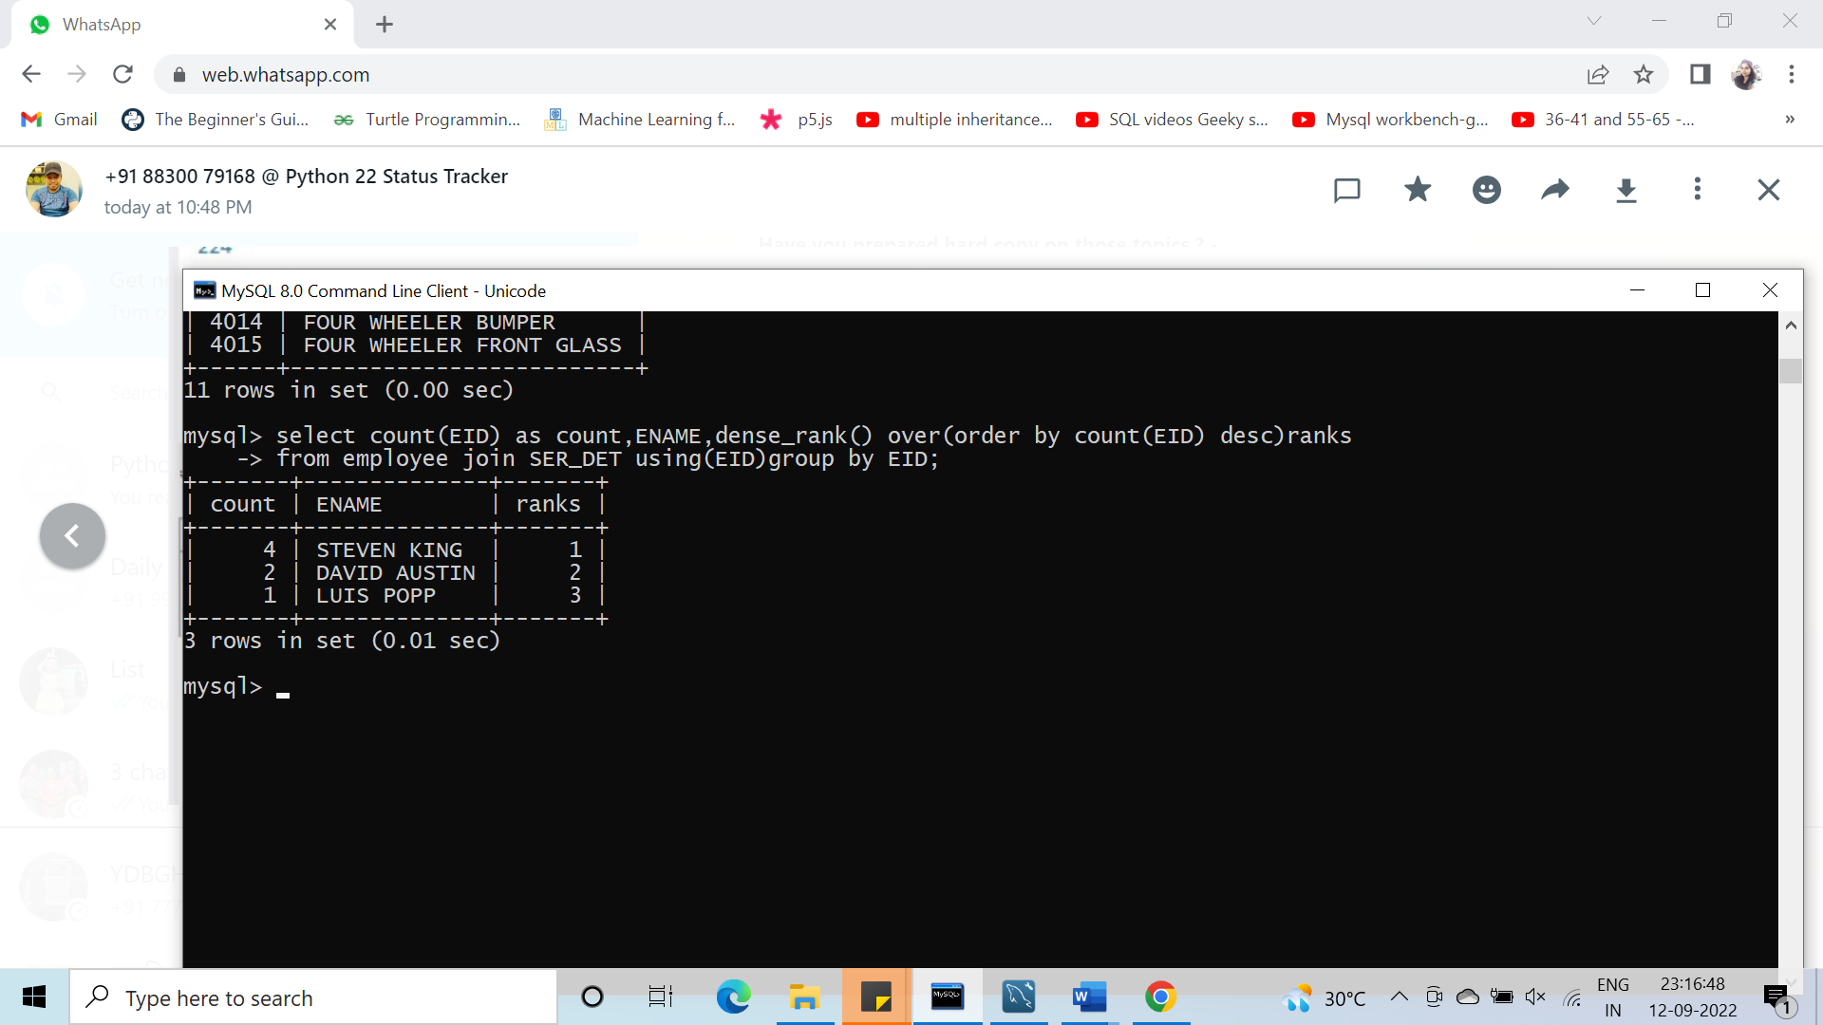

**Q 34 Display those employees who are working as Painter and fitter and who provide service and total count of service done by fitter and painter**

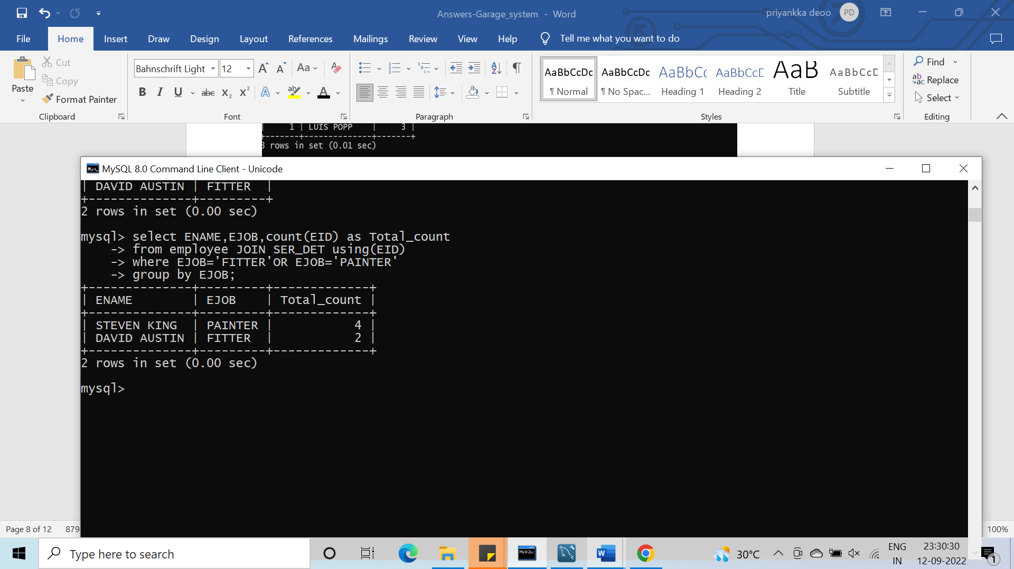

**Q35 Display employee salary and as per highest salary provide Grade to employee**

**(dense_rank())**

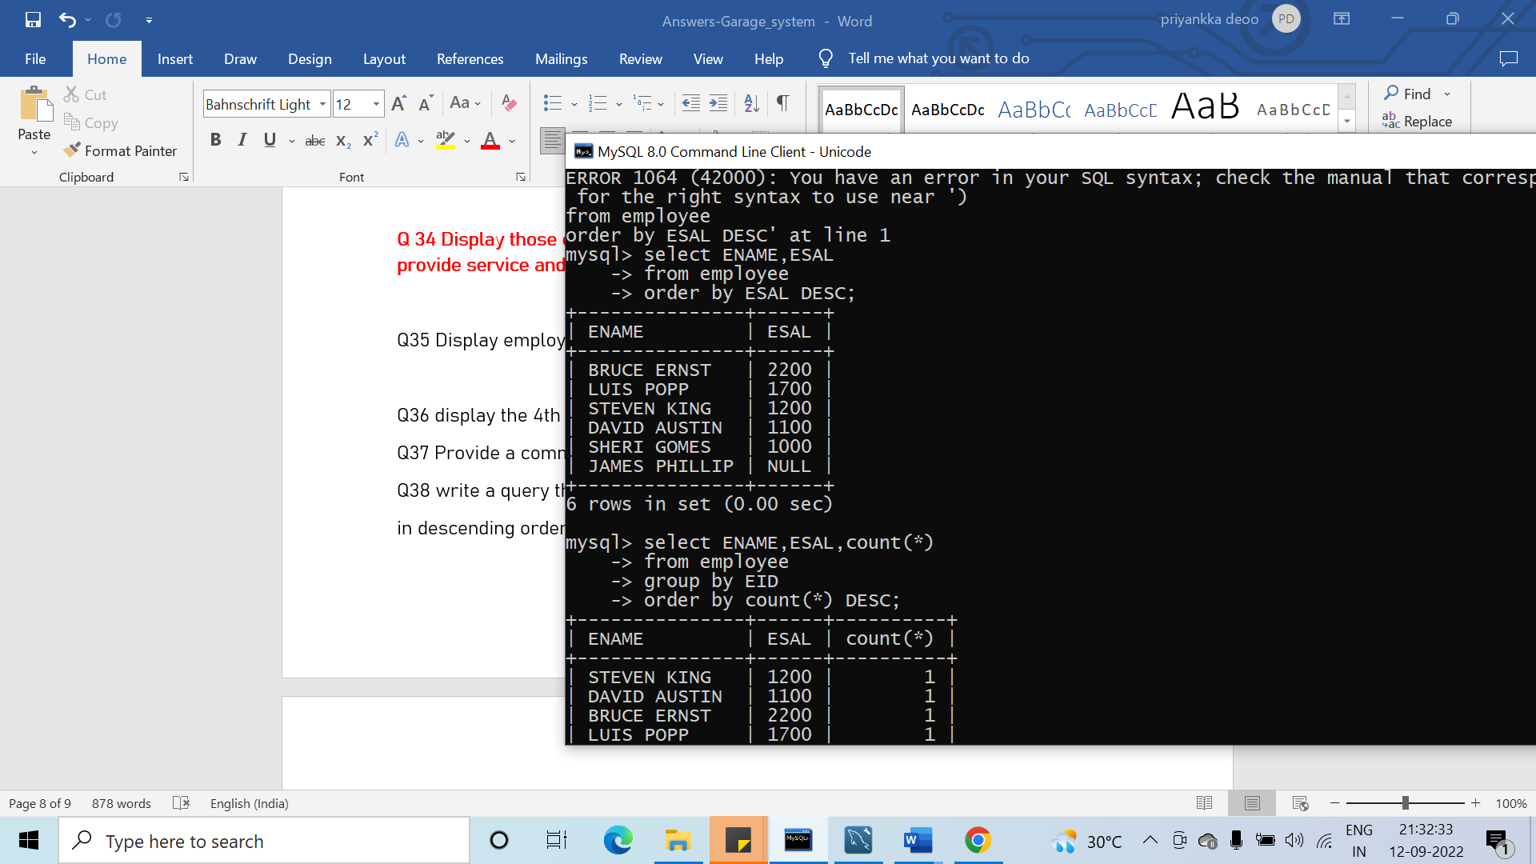

**Q36 display the 4th record of emp table without using group by and rowid**

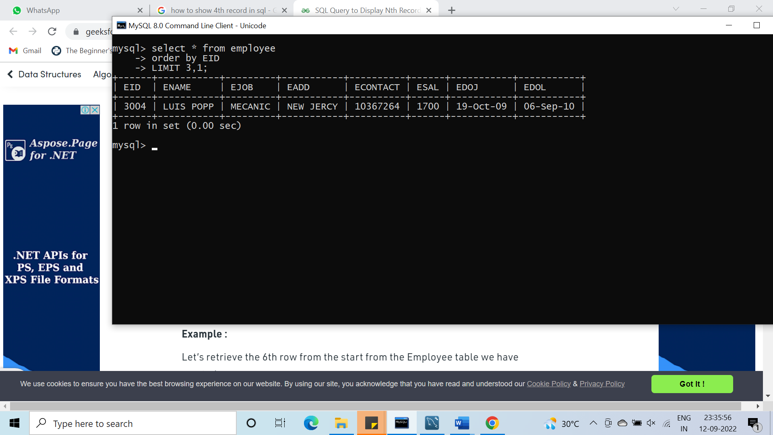

**Q37 Provide a commission 100 to employees who are not earning any commission.**

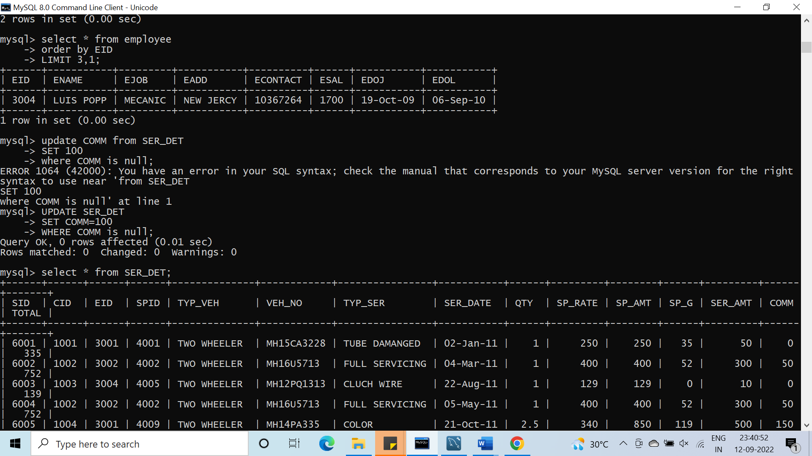

**Q38 write a query that totals no. of services for each day and place the results**

**in descending order**

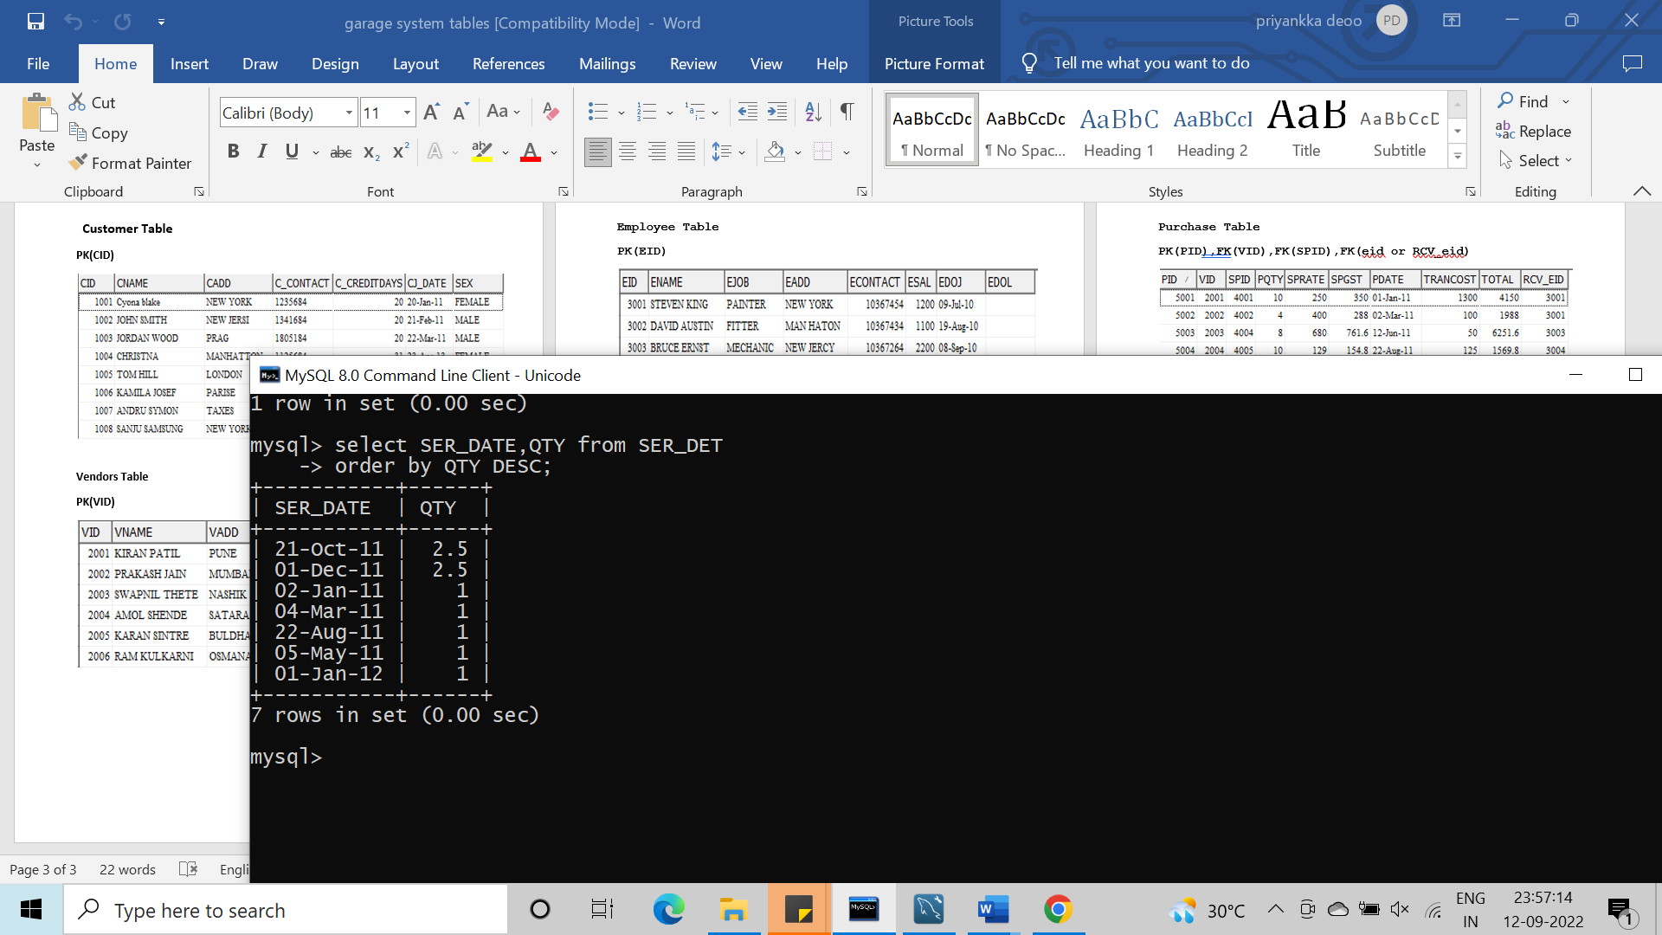

**Q39 Display the service details of those customer who belong from same city**

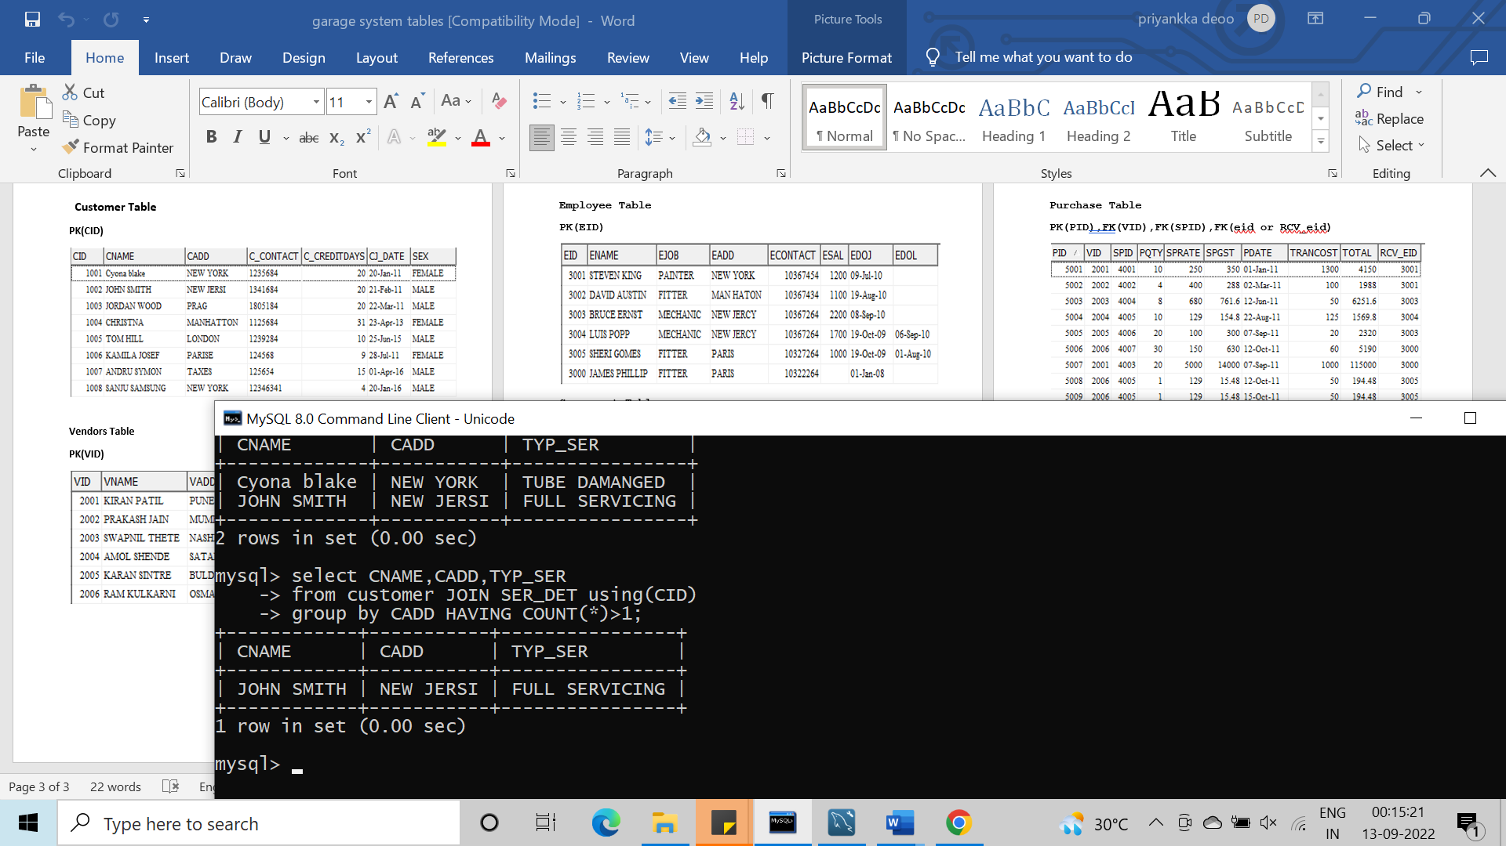

**Q40 write a query join customers table to itself to find all pairs of**

**customers service by a single employee**

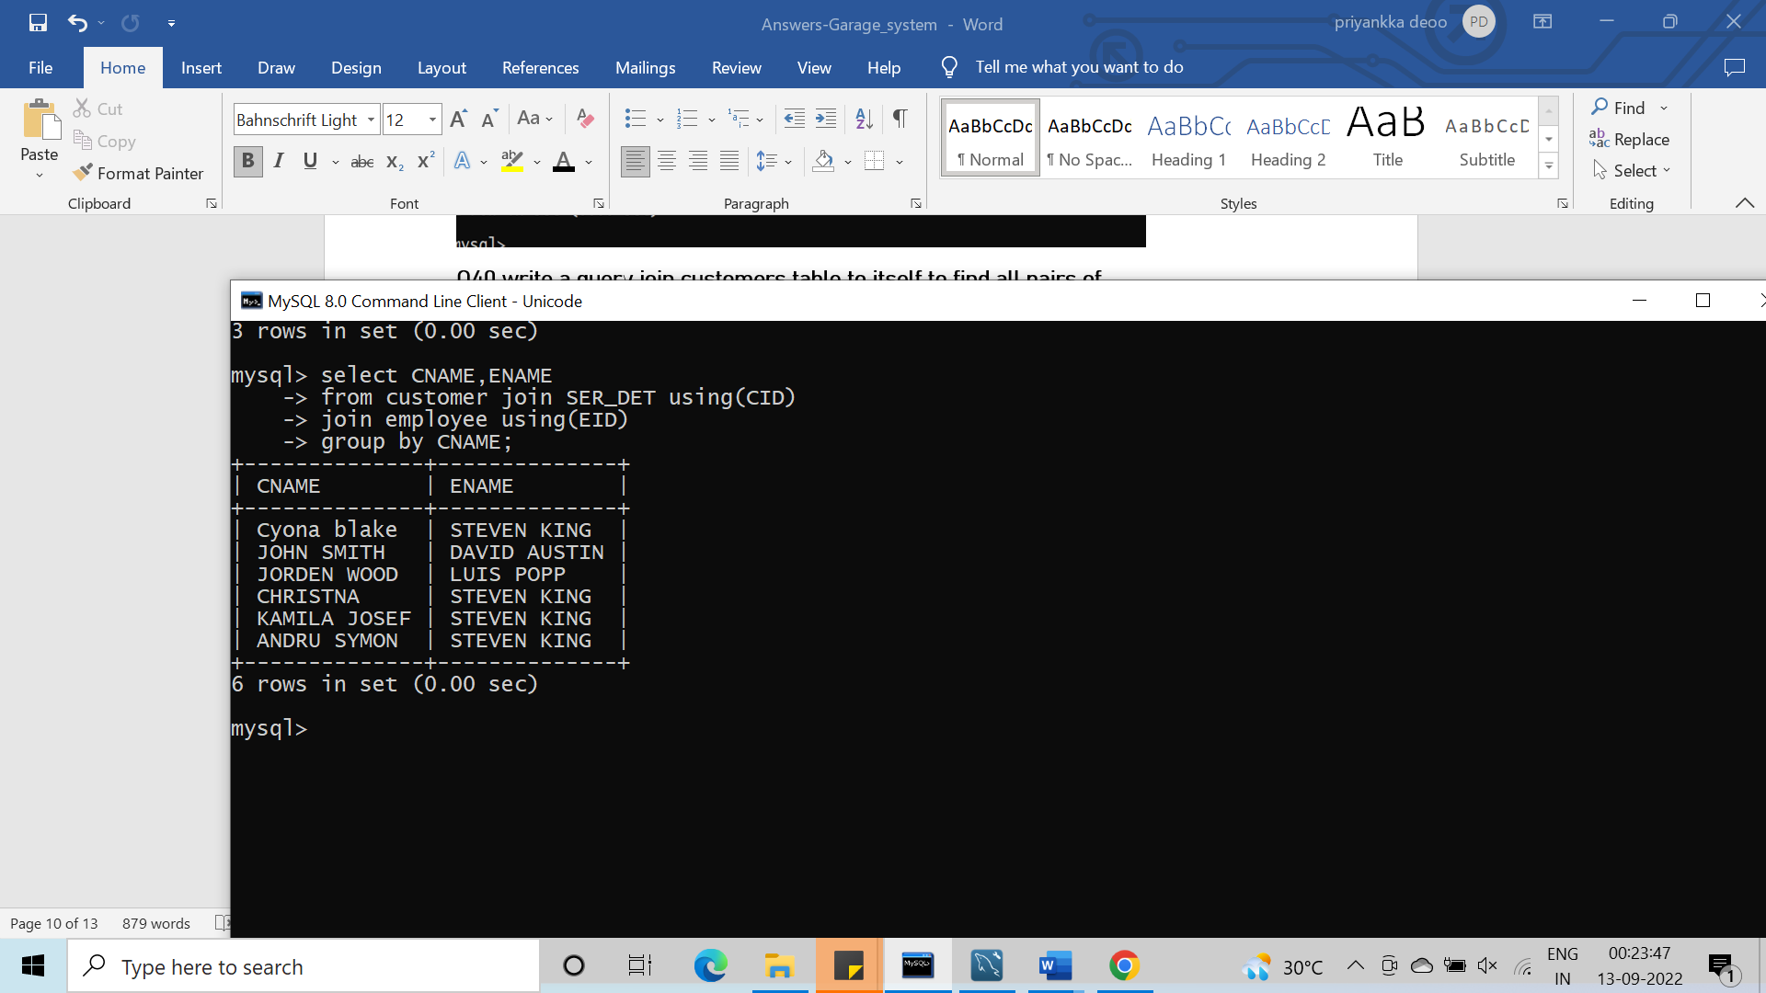

**Q41 List each service number follow by name of the customer who**

**made that service**

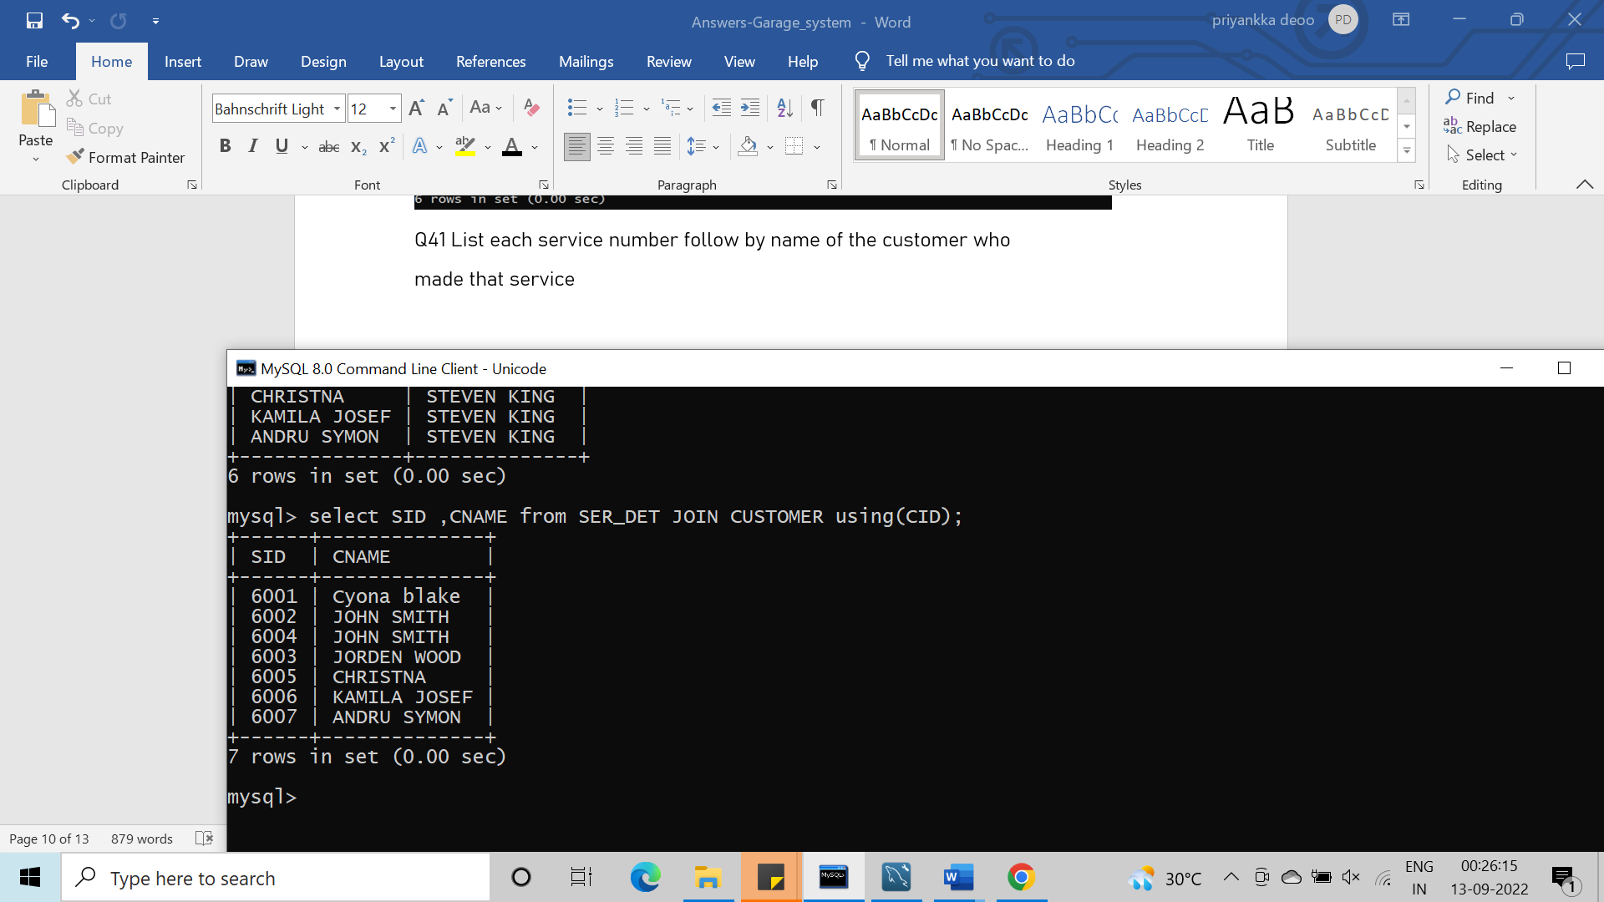

**Q42 Write a query to get details of employee and provide rating on basis of maximum services provide by employee. Note (rating should be like A, B, C, D)**

**Q43 Write a query to get maximum service amount of each customer with their customer details?**

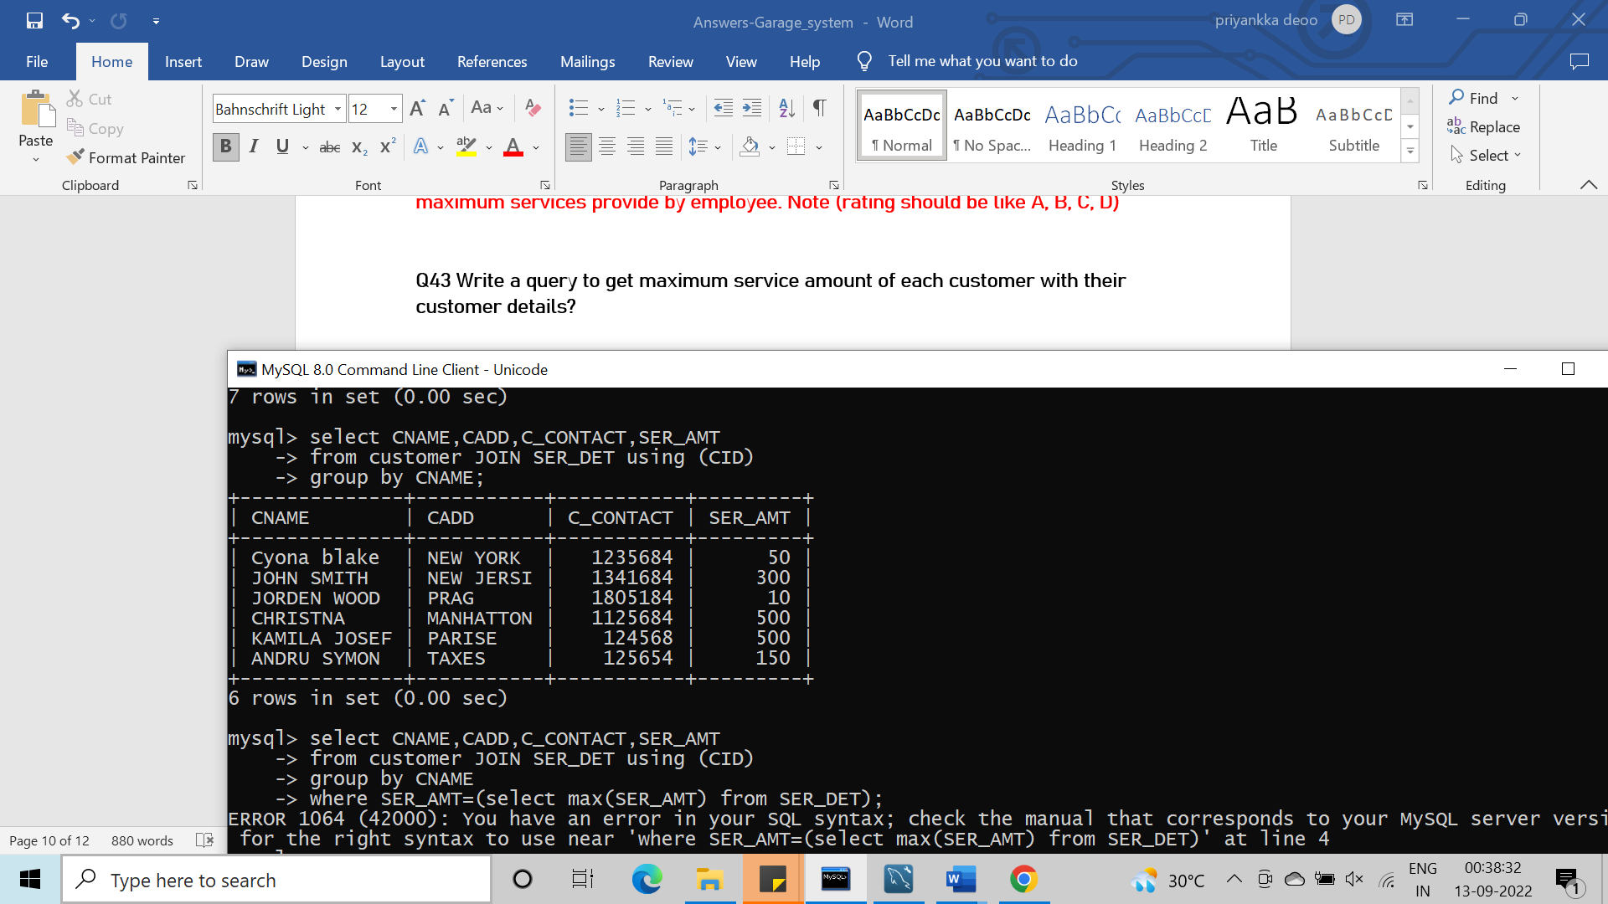

**Q44 Get the details of customers with his total no of services?**

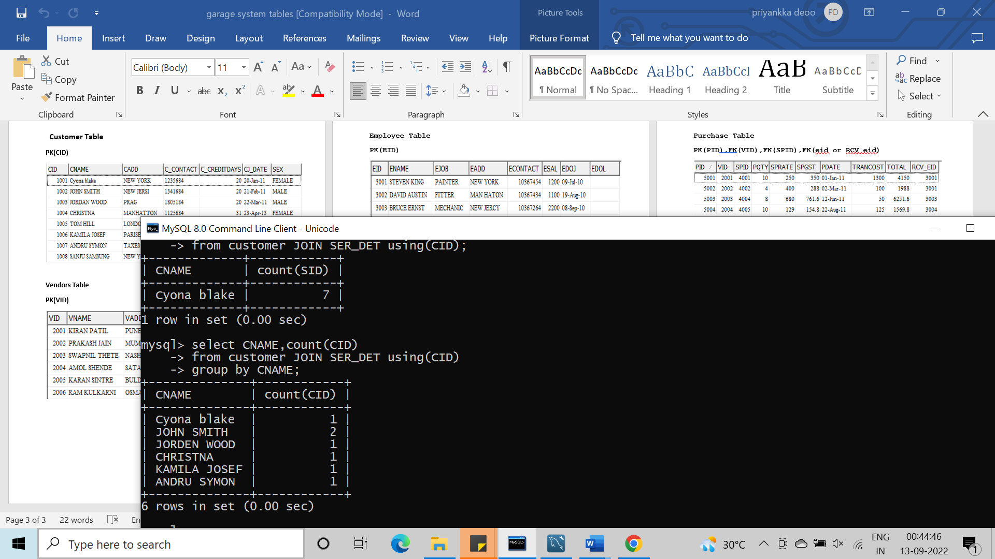

**Q45 From which location sparpart purchased with highest cost?**

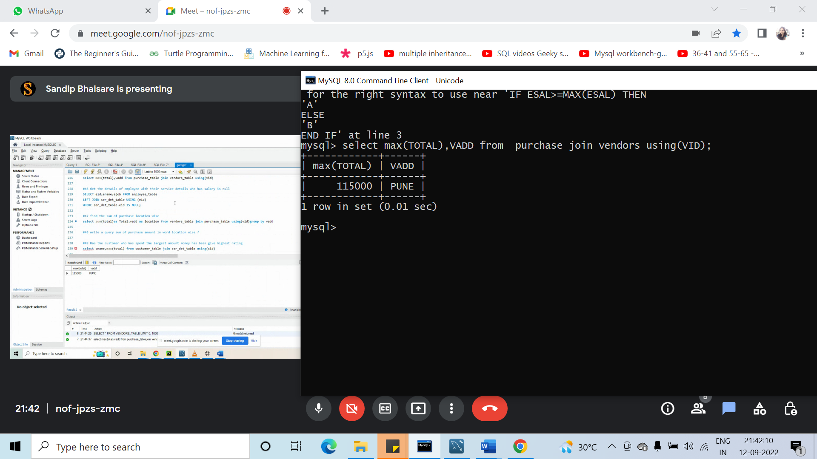

**Q46 Get the details of employee with their service details who has salary is null**

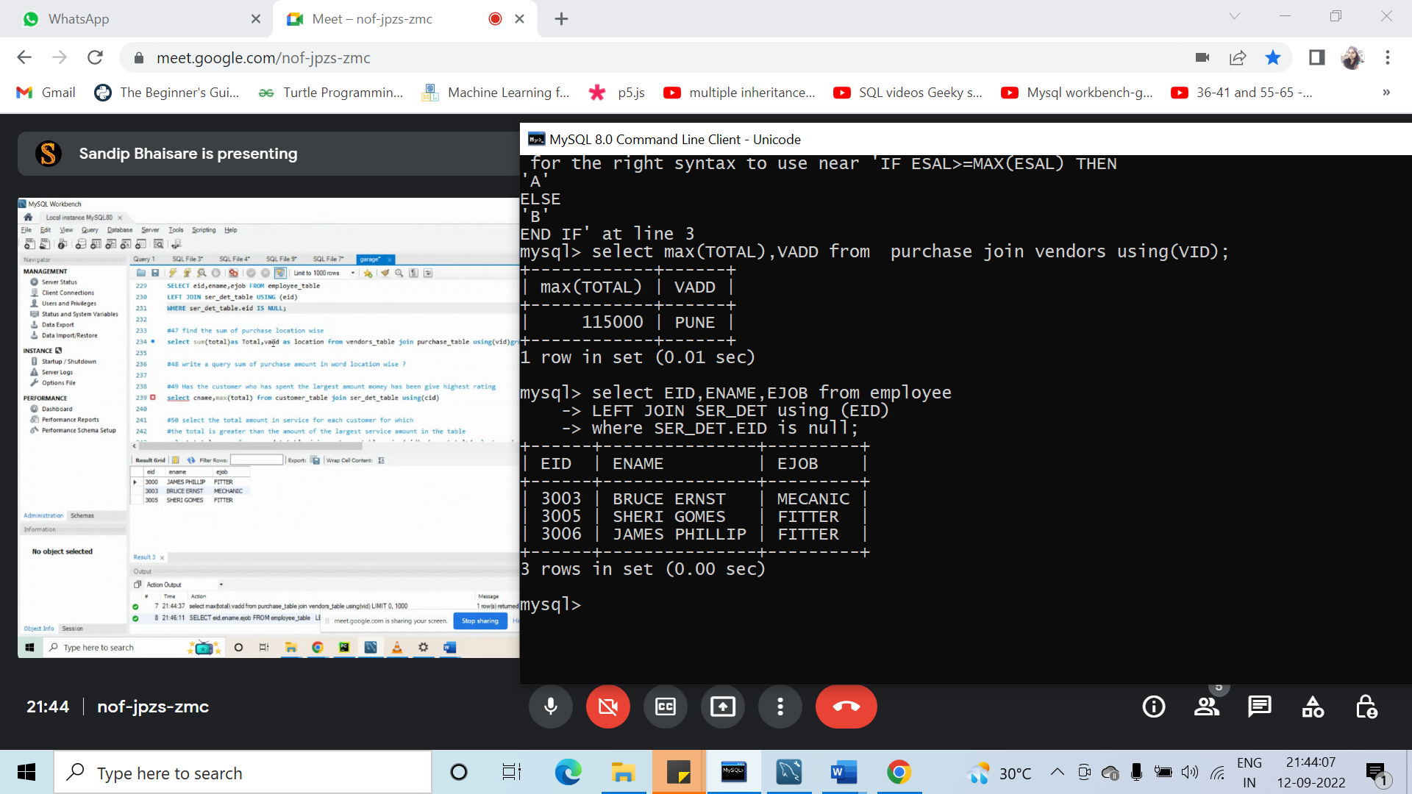

Q47 find the sum of purchase location wise

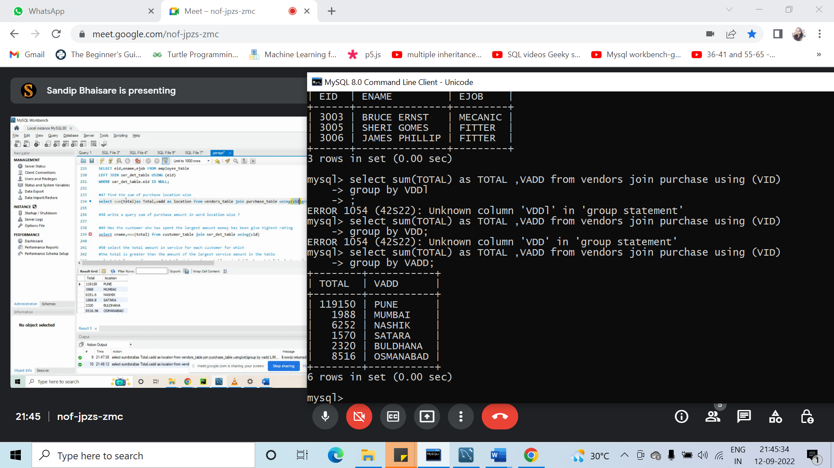

**Q48 write a query sum of purchase amount in word location wise?**

**Q49 Has the customer who has spent the largest amount money has**

**been give highest rating**

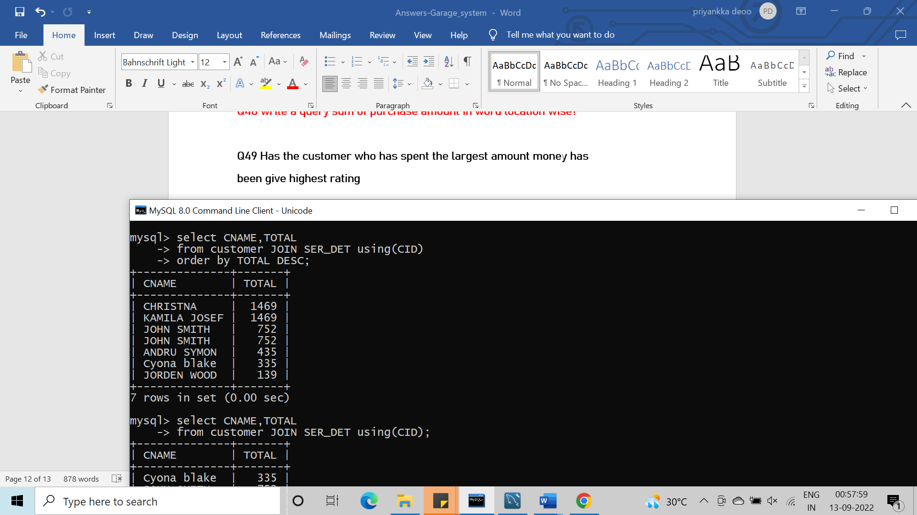

**Q50 select the total amount in service for each customer for which**

**the total is greater than the amount of the largest service amount in the table**

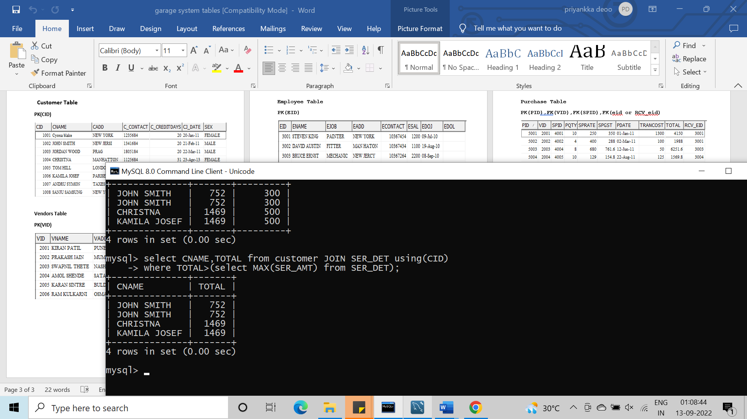

**Q51 List the customer name and sparepart name used for their vehicle and vehicle type**

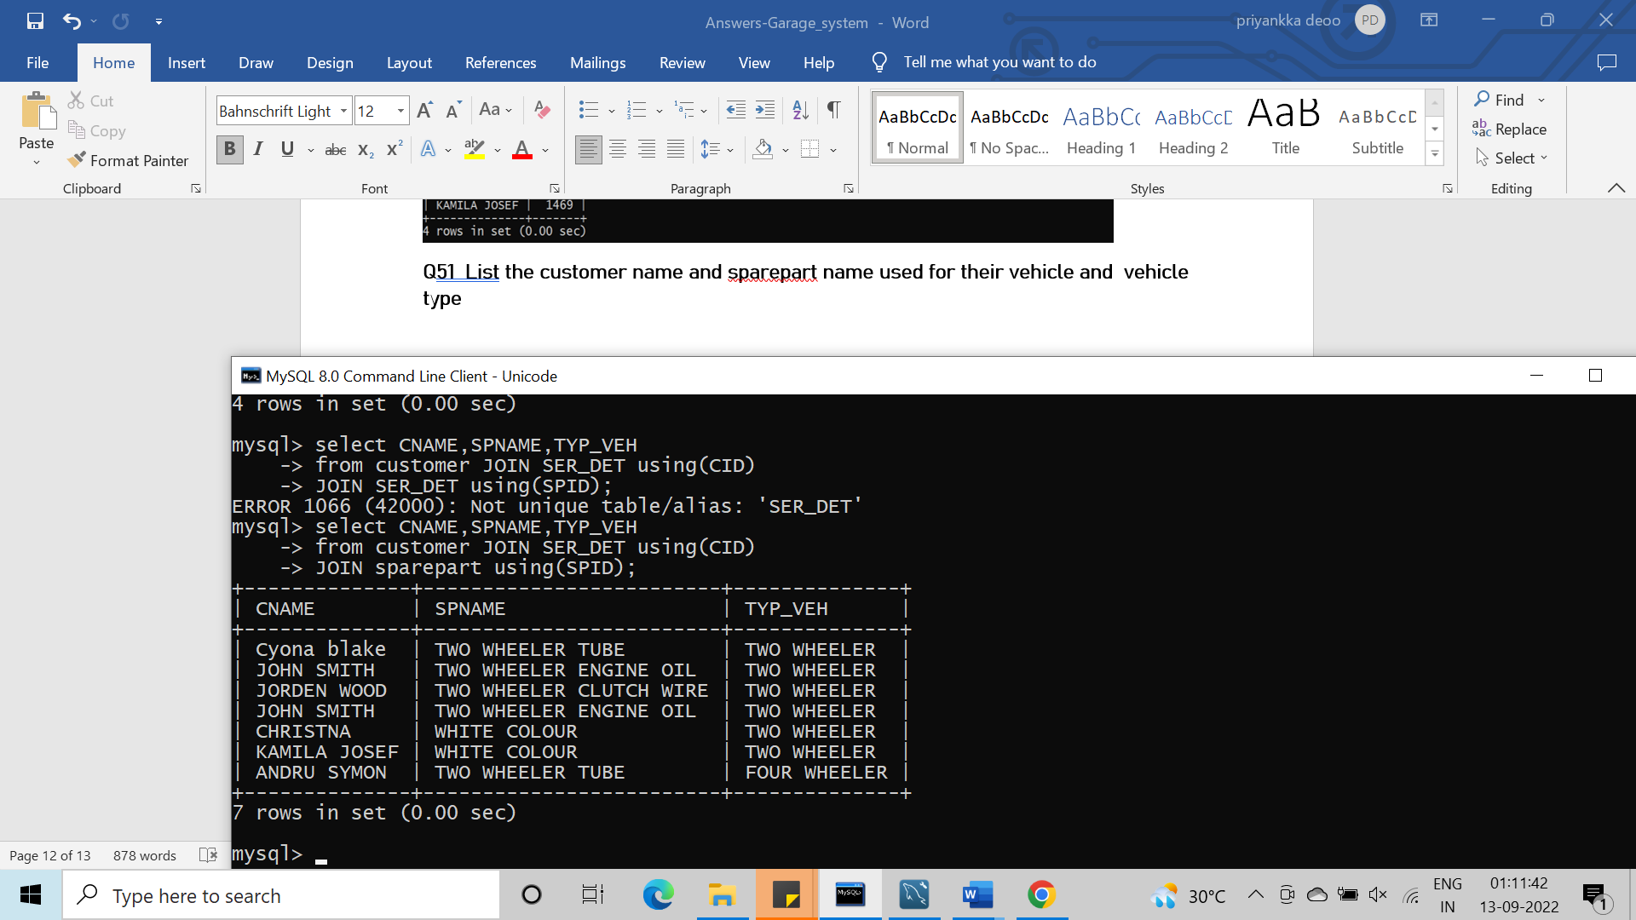

**Q52 Write a query to get spname ,ename,cname quantity ,rate ,service amount for record exist in service table**

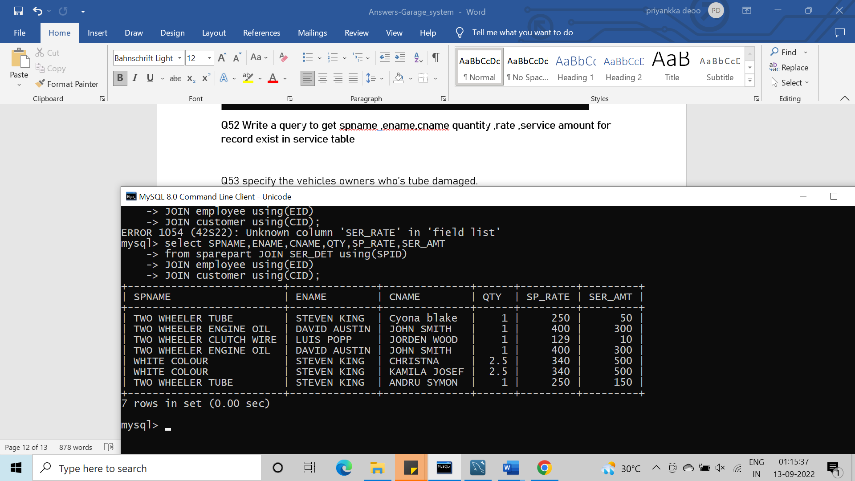

**Q53 specify the vehicles owners who’s tube damaged.**

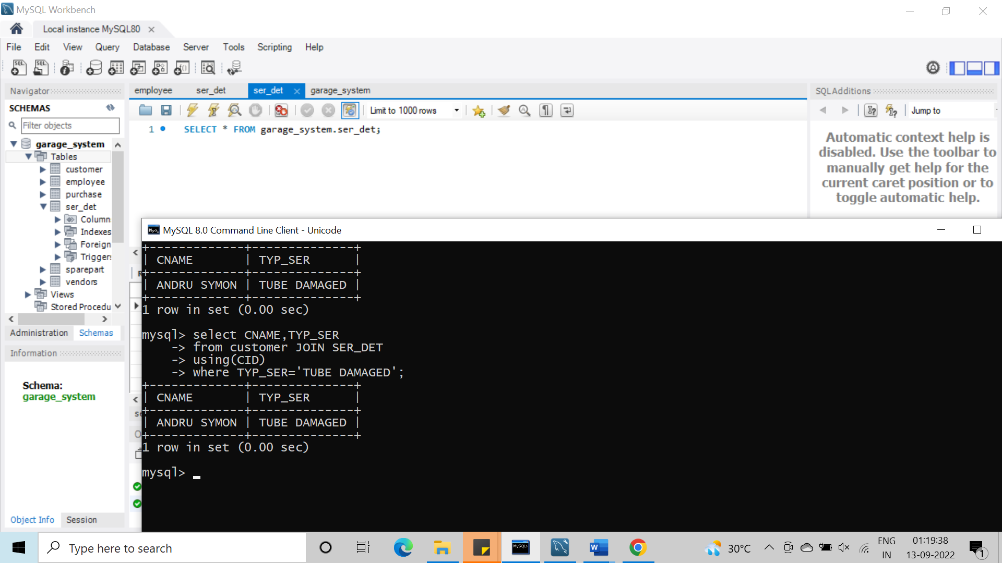

**Q.54 Specify the details who have taken full service.**

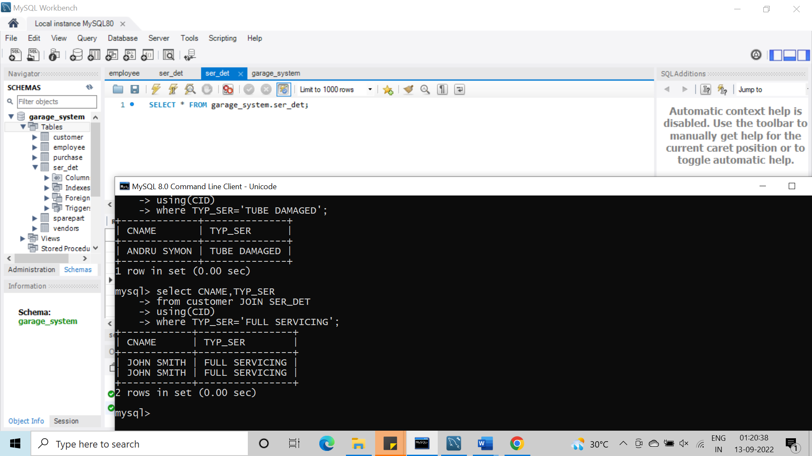

**Q.55 Select the employees who have not worked yet and left the job.**

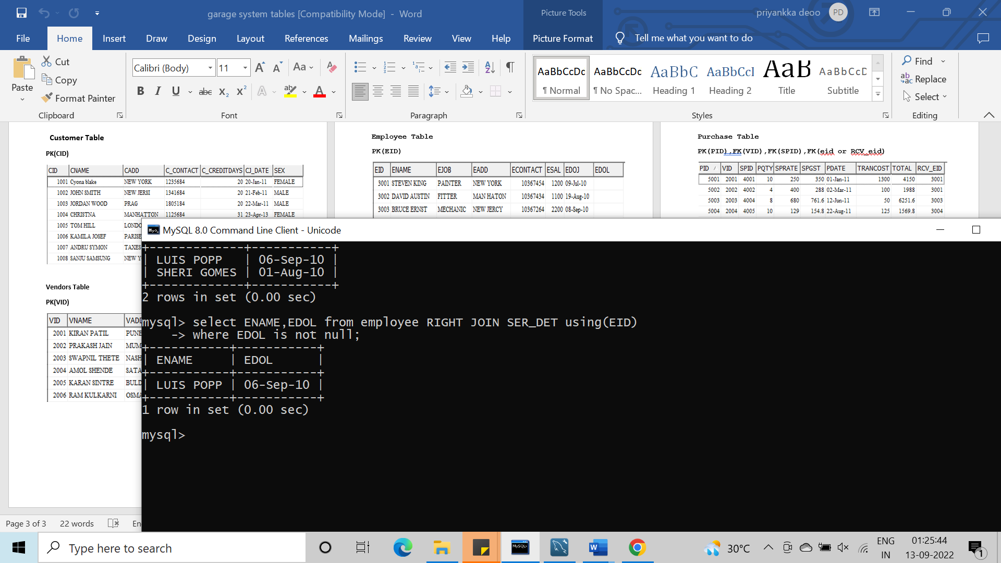

**Q.56 Select employee who have worked first ever.**

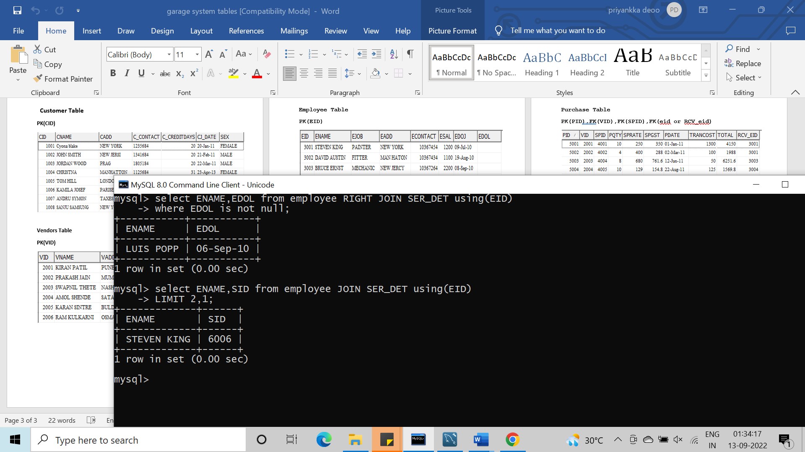

**Q.57 Display all records falling in odd date**

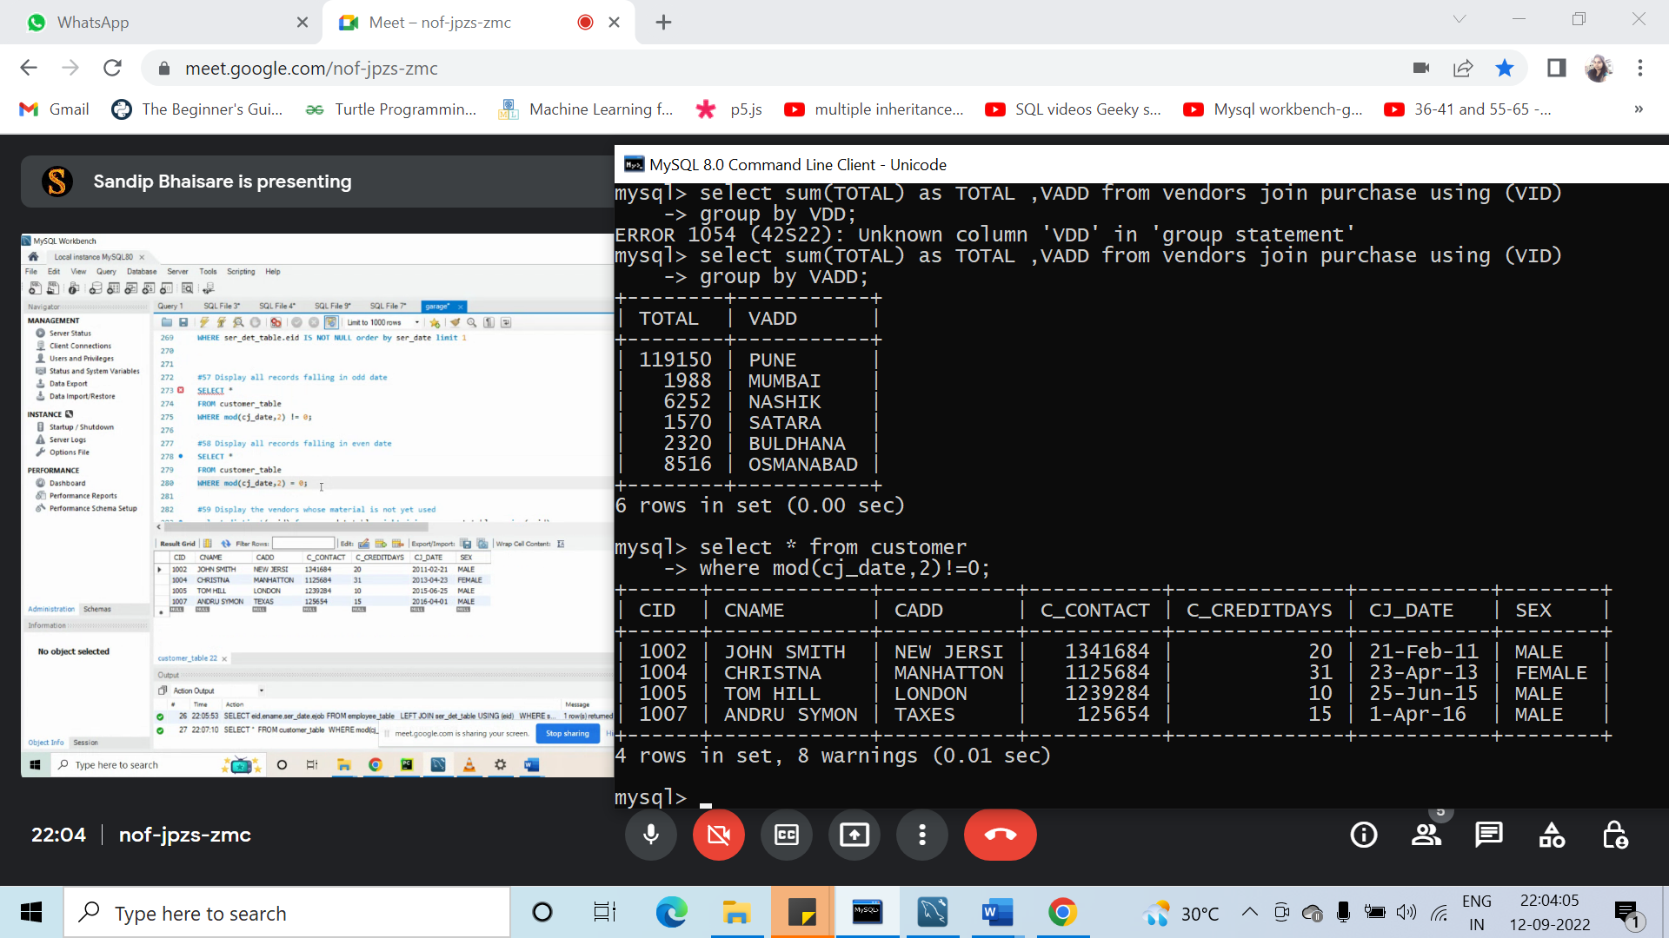

**Q.58 Display all records falling in even date**



**Q.59 Display the vendors whose material is not yet used.**

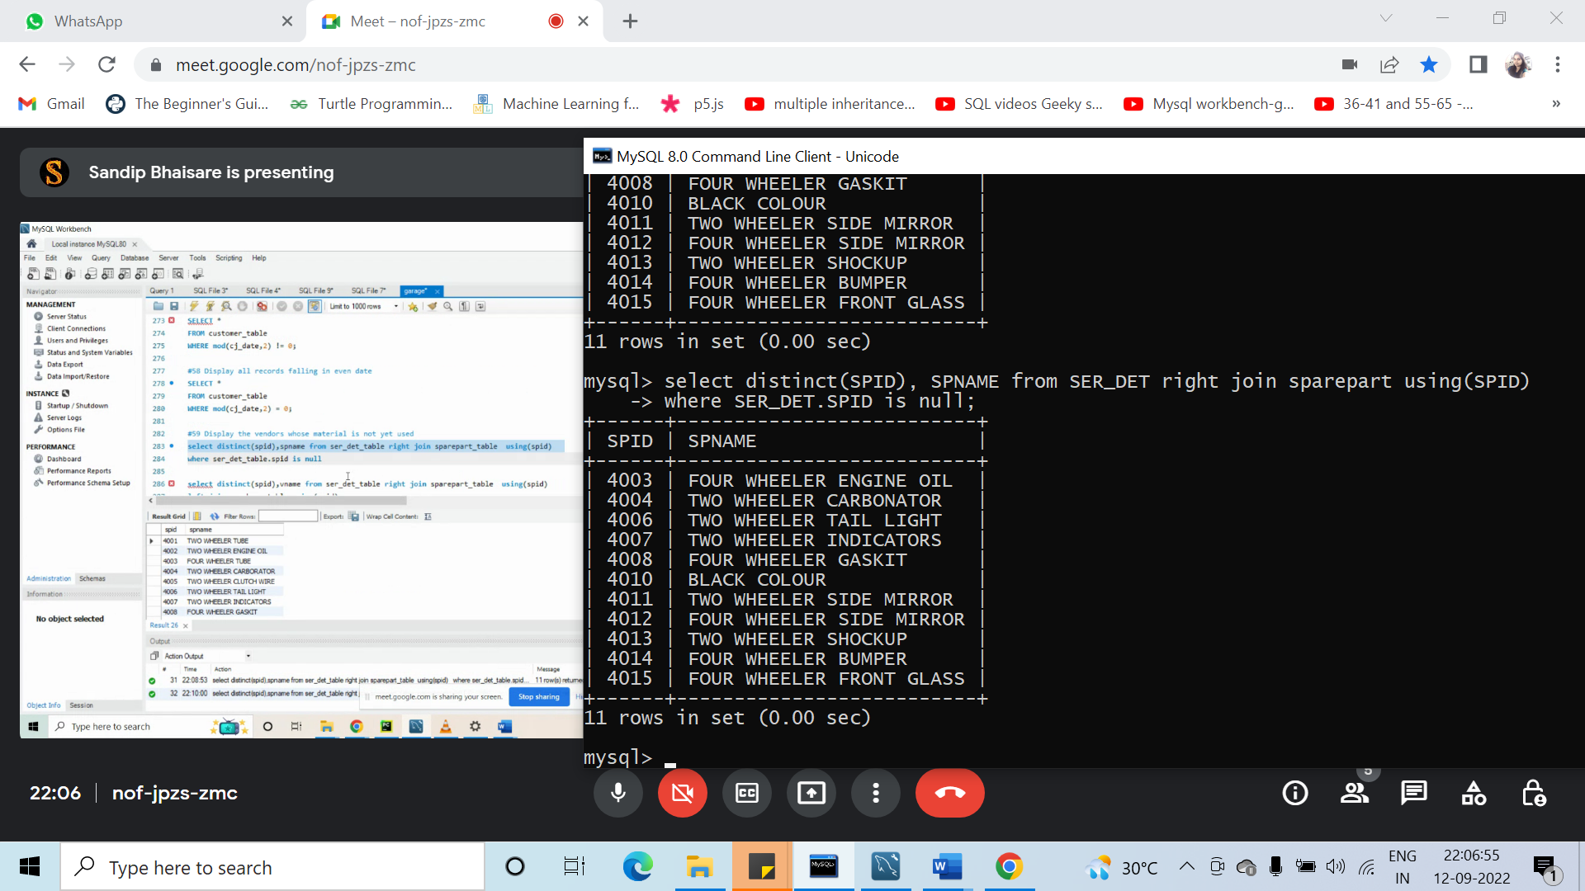

Q.60 Difference between purchase date and used date of spare part.

datediff